CHS2524 – Individual Project

University Of Huddersfield

Free online estate agent application

Muhammad Ikram

Student No: u1263673

Contents

**1. Introduction** 4

**1.1 Target audience** 4

**1.2 Project Time Plan** 4

**2 Literature Review** 5

**2.1 Introduction** 5

**2.2 Background** 5

**2.3 Real estate agencies websites** 6

**2.4 The end of traditional estate agent** 7

2.4.1 How internet changed UK real estate market. 7

2.4.2 What do real estate professional say about the impact of e-commerce on their business. 8

2.4.3 Factors influence consumers’ use of internet in their home buy and sell process. 9

2.4.4 Limitations 9

**2.5 Buying and selling property before internet.** 10

2.5.1 Buy and sell through estate agent 10

2.5.2 Buy and sell private 11

**2.6 Online estate agent VS traditional estate agents** 12

**2.7 Existing online estate agents application** 13

2.7.1 Zoopla.co.uk 13

2.7.2. Emoove.co.uk 15

2.7.3 Spareroom.co.uk 17

2.7.4 Existing online estate agent comparisons. 19

2.7.5 Understanding the current problem 21

**2.8 Research into tools and skills required** 24

2.8.1 Integrated Development environment (IDE) 24

2.8.2 Programming Languages 25

2.8.3 Version Control 27

**3- Requirements Specification** 28

**3.1 User and system requirements** 29

3.1.1 Functional requirements 29

3.2.2 Non-functional requirements 33

**4- Project planning** 35

**4.1 Development methodology** 35

4.1.1 Waterfall Methodology 35

4.1.2 Agile Methodology 36

4.1.3 Method chosen 37

**4.2 Justification of the chosen tools and software’s** 38

**4.3 Project risks** 41

**4.4 Project time management** 43

**4.5 Modelling** 43

4.5.1 Use case diagrams 43

4.5.2 Activity diagrams 49

**4.6 Database design** 49

4.6.1 Database tables 50

4.6.2 Entities & relationships 53

**4.7** **Product design** 55

4.7.1 Product design 55

4.7.2 Product prototyping 60

4.7.2.3 Home page prototype (Wireframe 1) 62

2.2.2 Information Architecture 66

# **1. Introduction**

The Internet has started to transform the way we buy and sell properties. When you next sell your home would you prefer to pay to 1.5% of sale price or sell for *FREE*? With rising cost of estate agents, it has become essential to use alternative ways to sell your property.

The aim of this project is to investigate alternative ways buying and selling property. The research focus will be on how Internet can play an estate agent role and be used as alternative way to sell properties. Current ways of buying and selling properties will be identified and compared. Further investigation will be carried out to identify any issues or concerns with the current buying and selling methods and new alternative way will be proposed and developed to solve the problem.

## **1.1 Target audience**

The project is about improving and re-establishing the online ways of buying and selling properties. Therefore, the finished product will be aimed at all individuals who will buy or sell properties on internet. In addition, the finished product will improve the user experience of buying and selling properties on internet so it will also be used to persuade people use “alternative way” to sell their properties and rather than using high street estate agent.

## **1.2 Project Time Plan**

30 weeks are allocated to complete this project. In order to complete the project within time frame, it will be broken down as follows:

**0 - 3 weeks**

Within the first three weeks, the project idea will be discussed and finalised with the supervisor. The project proposal will completed and presented to the supervisor. Further discussion will be held in regards to building project, writing report and producing poster.

**4 - 11 weeks**

The primary research which was used to write the proposal will be extended to complete the literature review. The project specification will be written up which will include project methodology, risks and tools that will be used to complete the project. The developing strategy will also be developed in order to start developing the product in the new term.

**12 - 22 weeks**

This will be the project development period. The development will be well under way and all of the main functionalities will be completed. As regular, discussion will take place with supervisor and process will be discussed. The testing strategy will also be developed to fix any errors that may occur during the development project.

**23 - 30 weeks**

At this point, the development of the project will be completed and testing will undertake. Result and collected and analysed. The final report will also be written at this stage.

# **2 Literature Review**

## **2.1 Introduction**

The research required for this project is quite vast. At first the research will focus on the current UK property market and ways of how people buy and sell properties. Comparison will make between the traditional and online ways of selling and buying properties. Furthermore, the online ways of buying and selling properties will be compared and the gap in the market will be identified.

Research into different programming languages and methodologies will also have to take place in order to choose the right programming language and methodology for this project. Furthermore, different tools such as Bitbucket and Sourcetree will also be researched in regards to planning the project, backing it up and developing it.

## **2.2 Background**

The use of internet changed the ways of how businesses operates and how individual consume products and services. Many companies now have “e-commerce” websites that allow that them to reach millions of customers that they could not reach before. The concept of “E-commerce” refers to the transaction of goods and services through electronic communication for example internet (Yan Tian, 2008). The impact of e-commerce is global and affects processes within businesses, between businesses and businesses and customers (Dixton Tom, Marston Andrew, 2010). Retailing has always been about marketing the product in effective way; getting the right product in the right place at right price. However disruptive technologies has changed retailing.

The evolution of e-commerce has also re-shaped the real estate industry. Currently, only 5.5% of the UK house sales are carried out through online estate agencies. However, the figure of UK house sales made on internet is expected to rise 50% by 2018 and 70% by 2020 (Mounty Harry, 2014). 90% of the UK home hunters begin their search for new home on internet before they go to the traditional estate agent to complete the purchase process.

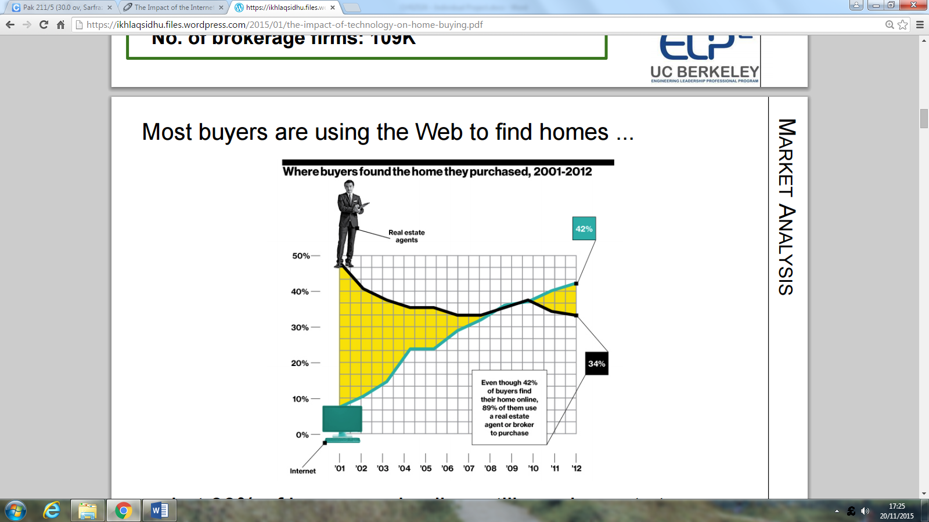

Figure 1: Chhatrapati, R.u.p.e.s.h., Kumar, P.a.n.k.a.j., McCluskey, S.c.o.t.t., Mills, R.o.b., & Viswanathan, S.o.u.m.y.a. (2012).

The trend shown on figure 3 also proves the fact that online way of buying and selling homes is taking over real estate agents. According to the figure 3, the figure of people using online way to purchase raised from 0 to 42% between 2001 and 2012. In same period of time, the figure of people using estate agents to buy home dropped from 50% to 34%. The trend indicates the use of Internet is taking over the traditional way of buying and selling properties.

## **2.3 Real estate agencies websites**

According to Harold Gee (2010) websites has enabled real estate agencies to become more ambitious. There were around 100 real estate websites at the beginning of 1995. However, by 1999 that number had grown to more than 200,000 ((James E. Littlefield Yeqing Bao Don L. Cook, 2000). The rapid growing of internet has enabled consumers to purchase and sell their homes in most convince and efficient way.

The growing number of websites has created competition among companies for home buyers and sellers. The growing number of buyers buying or selling home on internet expect high level of expectations and demand for sophisticated search engines (Harold Gee, 2010). Websites portals has now enabled businesses to deliver required high level of expectations through various function which they can have on website. One of the function could be search criteria which browser can use to specify a price range, location, number of bedrooms, style and type. According to NAR survey, 84% of the buyers searched house listening’s on internet in 2007 (Harold Gee, 2010)

## **2.4 The end of traditional estate agent**

### 2.4.1 How internet changed UK real estate market.

The impact of technology has revolutionised the UK property market (Sami Mughal, 2015). The technology is also having a dramatic impact on individual behaviour; customers are now using Internet to buy and sell their properties. According to the Jennifer Rowley (2005) the inherent attraction of online estate agency are:

* *“Global, national and regional reach which make this channel particularly attractive for matching properties and customers in certain property categories”.*
* *“Customer can potentially access a wide range of properties, being sold by numerous estate agents, by consulting one of the website that is supported by a consortium of estate agencies”.*
* “*Potential for the elimination of some or all of the significant costs associated with estate agent service delivery through high street branches.”*
* “*Potential for innovative approaches to depicting properties online, using digital photography and virtual reality coupled with other hi-Tec techniques.”*

### 2.4.2 What do real estate professional say about the impact of e-commerce on their business.

Cheston McGuire (2012) speaks to some of the real estate professionals about how technology has changed the way they do business.

Kathy Connelly, SCRP, senior vice president of corporate service believes that technology has changed the shape of real estate agent and customer now started to look into online ways of buying and selling properties (Cheston McGuire, 2012). When customer wants to buy or sell property, they will first look at Internet. The habit of customer buying and selling online will mean they are now less likely to use traditional estate agent. The role of traditional estate agent 7 distinct steps: a) listening the property b) advertising the listening c) finding a buyer d) helping buyer to find the property according to his requirements e) negotiating the price f) removing any contract contingencies and g) closing the sale.

Anita Clark (2014) believes that customers are educated enough now to go online and do their own research about property market and how to buy and sell their property (Anita Clark, 2014). Anita believes since Internet is everywhere now therefore customers have ability to go online and do their own research about their needs. She believes customers are smart enough to do their homework. They understand the value of money and the amount of money they can save by not using traditional estate agent services.

Lynn Pineda states Internet has triggered more competitions within the property market industry. She believes since Internet came into existence, the competition between different firms increased (Lynn Pineda, 2014). E-commerce forced all businesses to have websites in order to stay competitive. Therefore, the competition increased meaning customers now have choice to look for best product at best price. The online competition influence real estate as customers changed the way to buy and sell properties. The e-commerce also influenced the customer behaviour. Like other goods, customers are also now using online ways to buy and sell their properties.

### 2.4.3 Factors influence consumers’ use of internet in their home buy and sell process.

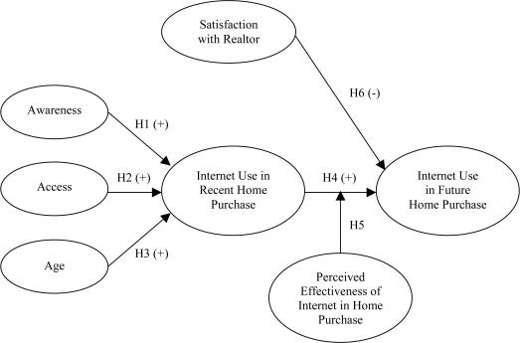

Figure 2: Consumers internet use in home buy and sell (James E. Littlefield Yeqing Bao Don L. Cook, 2000)

* **Awareness:** Internet has given access to find out house related information in few clicks. Buyers and sellers can look can carry out their own research to find out information they need about to sell their home or buy one.
* **Access:** Access to internet has increased rapidly in past decade. People now use WI-FI to access internet. Furthermore, smart phones also given additional access to consumers. So now house hunters can hunt house anywhere they want.
* **Age:** People from different age group may or may not use internet to hunt or sell house. Young people tend to use online estate agent more compared to old people.

### 2.4.4 Limitations

Even though internet has empowered buyers and sellers however it also beings some of the factors that may influence the process of buying and selling property online. One of the factors is customer ability to make an appropriate decision. Internet has given user access to millions of properties, making their life hard to make an appropriate. User was able to discuss property with real estate agent however on internet, user will have to carry out his own research to make appropriate decision.

Property purchase is a long process and requires significance commitments. Therefore, buyers may want to work with specialist people who will bring experience and expertise to the process of purchase and the final sale of property (Jennifer Rowley, 2005)

It might be first experience for someone to sell their property and they may not be aware of the process. Therefore, they will tend to pay someone to give them advice or to manage the sale of their house, interact with customers and complete the selling process.

## **2.5 Buying and selling property before internet.**

There are 2 common methods which was used as to buy and sell home before internet. Depending on consumer personal circumstances, they can use any of the following method (Gavin Brazg, 2007).

* Buy & Sell house through estate agent.
* Buy & Sell house private

### 2.5.1 Buy and sell through estate agent

“93% of home sales involve an agent to some degree.” (Ted Ricasa, 2015). Home owners don’t want to risk when it comes to sell home. In addition, there may be cases where home owner don’t know any alternatives way of selling property therefore for all these reasons they tend to use high street estate agent to sell their home. To sell property, consumer would find a suitable estate agent and give him property details. The estate agent would advertise the property on various channels and arrange viewings as well as price negotiation

The figure 2 above shows, 89% of the buyers still use agents to buy property. This way is commonly used because it’s more secure, trusted and agents have the best knowledge about the housing market. When buying property, customer would contact various estate agents and specify his requirements. The agent would find property that matches client requirement and negotiate property on behalf of the seller.

### 2.5.2 Buy and sell private

The fast growing of internet means, you can market your home yourself. There are companies which you could find through internet, will help you to sell your home yourself. They will provide with sale signs and other helpful resources that enable you to market your home yourself. And of course these private companies will guide you all the way through selling process and will save you’re a lot of money.

Buying a property privately form the owner is much easier than buying through estate agent or at auctions. When you buying privately, you will have more control over the buying process, you can get immediate decisions on any offers that you make and in generally this process will have minimum stress. However there are other factors that may be involved in this process such as property legalisation, price negotiation and how much you can afford.

## **2.6 Online estate agent VS traditional estate agents**

|  |  |  |
| --- | --- | --- |
|  | **Traditional Agent** | **Online Agent** |
| **Cost** | Between 1% - 6% on average of your property price on completion of the sale | Online estate agent charge one off cost of between £500 to £1000 |
| **Accessibility** | Generally open 9:00 till 5:00 Monday to Saturday. | 24/7, 365 days a week |
| **Valuation** | The service of valuation often comes at additional costs through separate body. | Member of staff from online agent will visit the property to work out the valuation and take photographs to go on property profile on website. |
| **Circulation** | The property will be displayed on their window and UK leading property websites Zoopla and Rightmove. | The listening will appear on UK leading property website Zoopla and Rightmove. Plus on the online agent website. |
| **General knowledge** | Agents have good general knowledge about the property market. | Customers can do their own homework. If they are busy with their schedule, they can get the information from online agent at no extra fee. |
| **Viewings** | Member of estate agent may have to go with every customer for viewings. | 50% of the buyers would prefer owner to host the viewing, as they know best about the property. Therefore online agent will book viewings for you that suit your time and you will have to do the rest. |
| **Offers** | Let the estate agent initiate a bidding war for your property. Although this sounds tempting it is often only to achieve bonus fee’s agreed on in your contract. These selfish intentions can often result in loss of potential buyers. | They qualify all buyers prior to considering them. This saves seller’s time and they only deal with genuine offers. We achieve on average 99% of asking price for our customers, that's 3% higher than the industry average. |

So far we looked at traditional estate agent and how internet transformed them to online estate agent. Now let’s compare the traditional and online estate agent.

## **2.7 Existing online estate agents application**

Before carrying out research on the tools and specification that would be considered for implementations in the product, we should see what other online estate agent application are available in the industry. After carrying out some research, it was found that there are various online estate agent website that allows users customers to buy and sell properties.

The research also indicates that property portals are used to deliver excellent customer service. Property portals can include many types of information. Some of the information found within the property portals is:

* Content
* Links
* Search facility
* Registration

I will use above key points in order to examine some of the existing online estate agencies websites.

### 2.7.1 Zoopla.co.uk

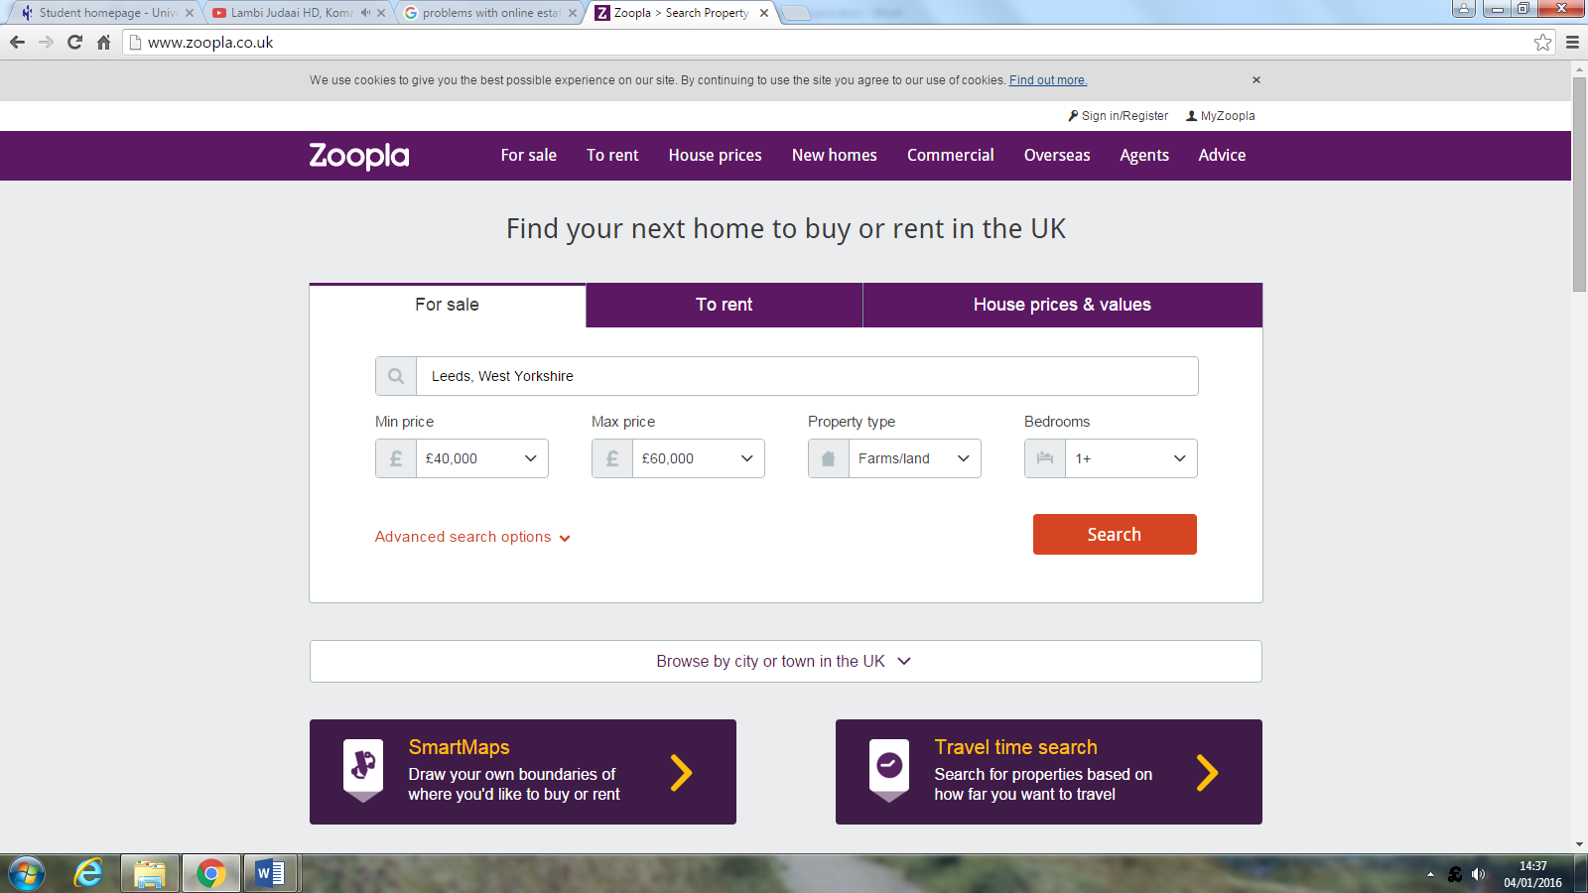

Zoopla was launched in 2008 and now is the UK property leading website. There focus is on helping customers to find their next home and providing them access to information such as history of sold prices, area trends and value estimates.

**Content:** Zoopla has a lot of content on its wbesite which includes informaton about buying home, renting home, buying overseas and seeking adivce. The content has an balance between graphics and text, which makes website look good structured.

**Links**:Zoopla has a large number of links across it’s website. The links lead to offers pages, banners ads and other external websites such as facebook.

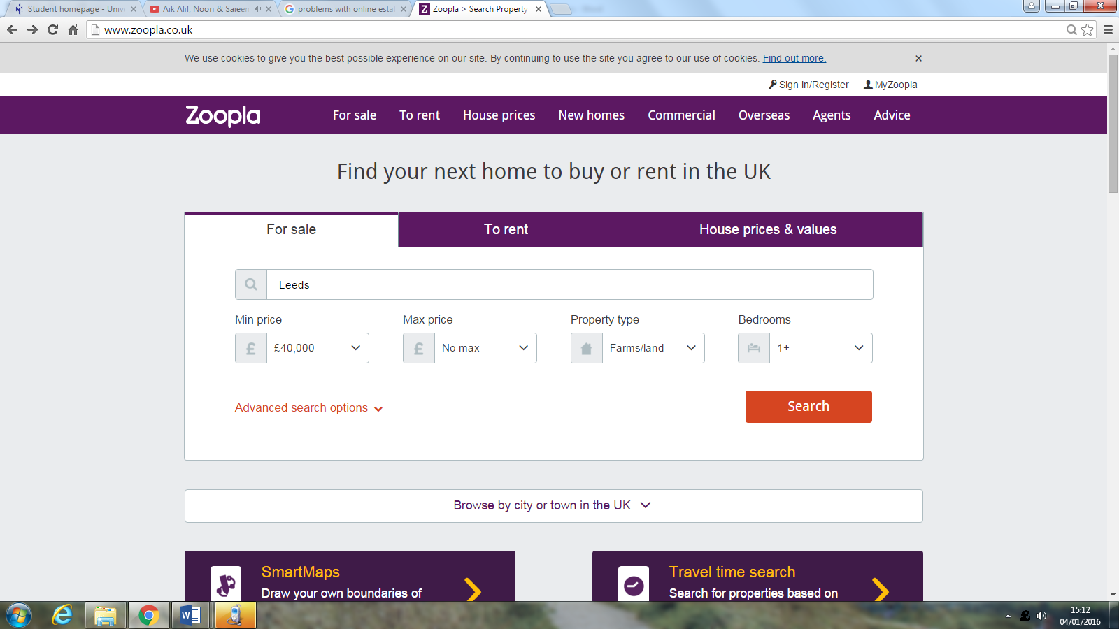

**Search facility:** The website has a search criteria on the home page where it asks user to specify location, price, number of bedrooms and property type. We can tell this website is specifically targeted for house hunters as it doesn’t allow user sell properties. Once user specify their requirements, the website then preforms search for properties that matches user requirements.

**Regristration:** To buy porperty off Zoopla, customers would need to be registered first. By registering with zoopla, customer can manage their every day account on the go. They will be able to contact sellers, save property to favurite and also add notes to properties form them to have a look at later.

Even though the company has great setup however, they are still facing some bad customer experiences issues. According to TrustPilot.com (customer experience sharing website), here are some of the comments about Zoopla.

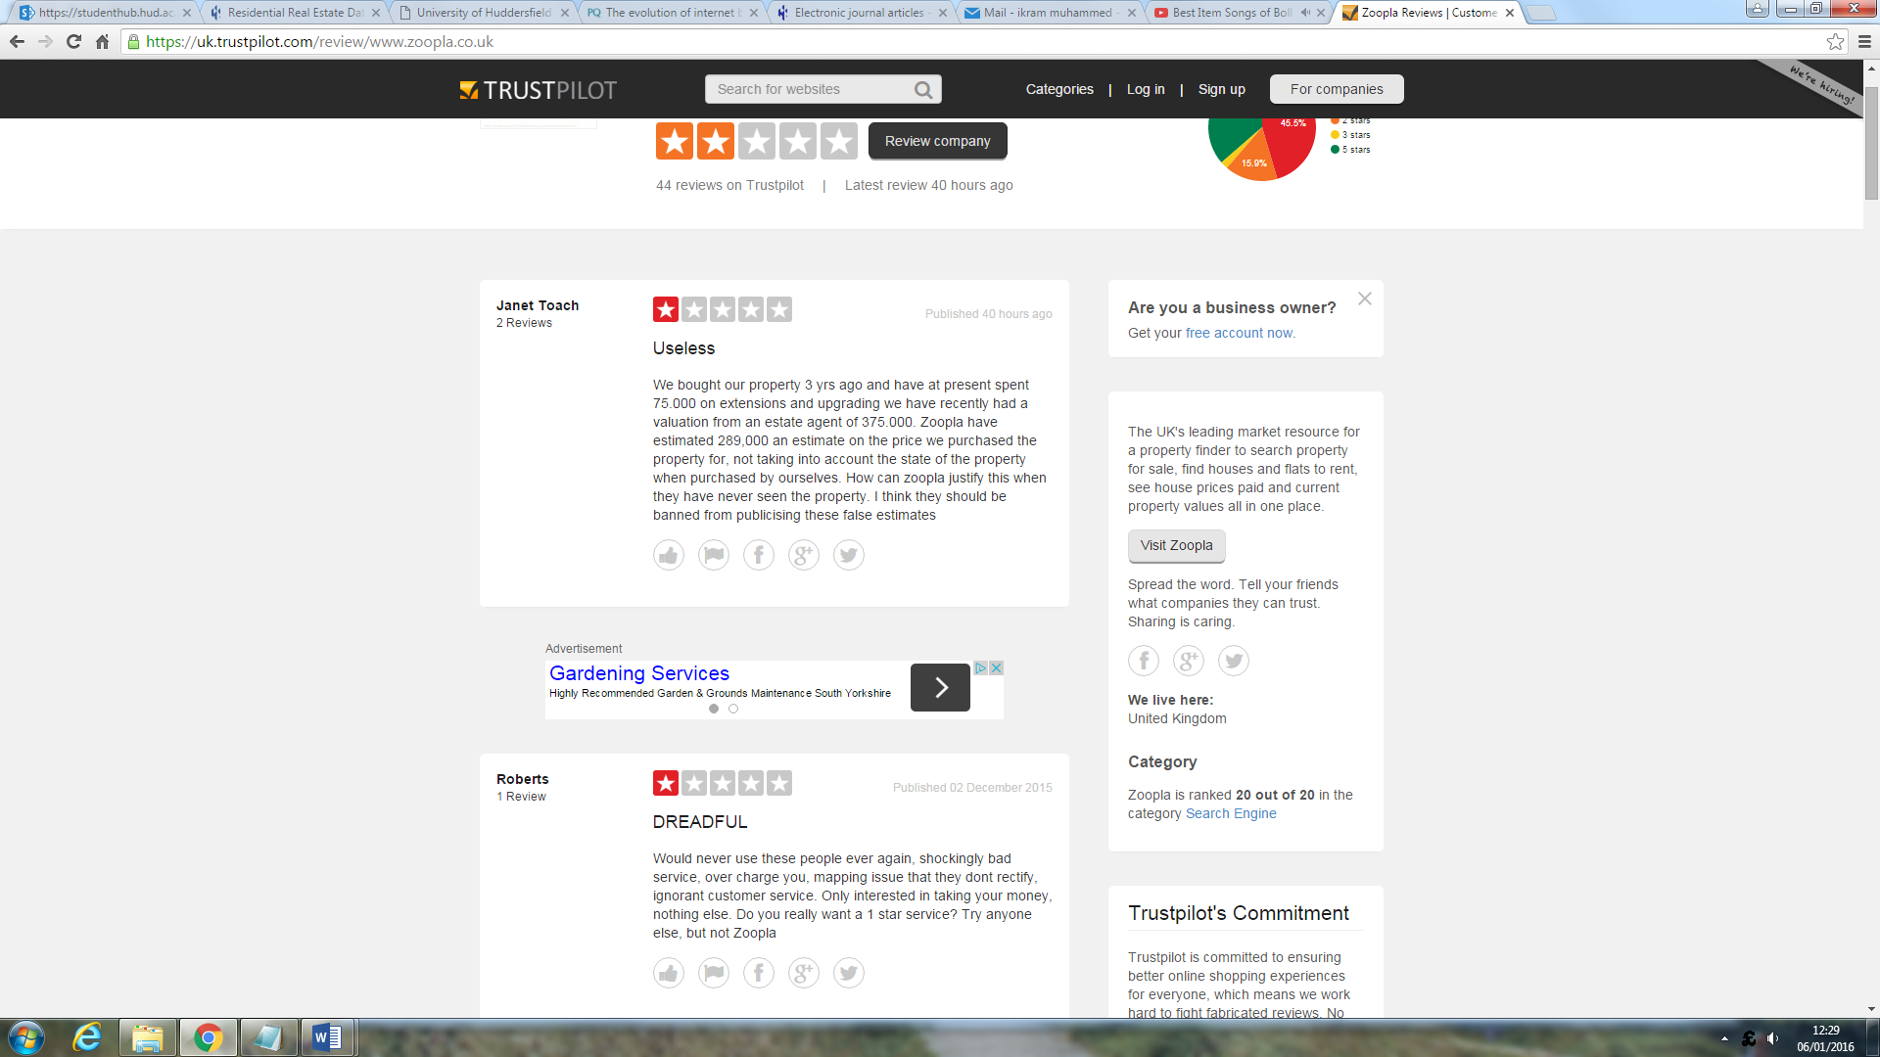

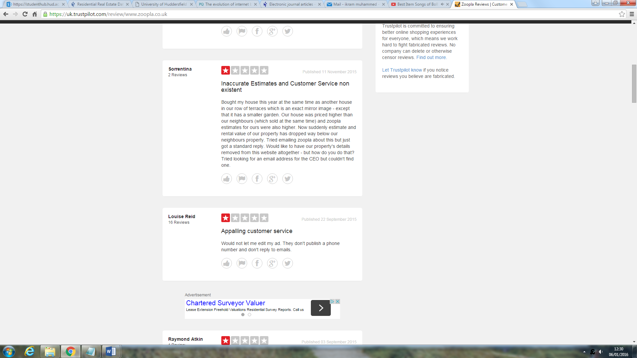

Zoopla does not allow user to edit their properties. This can be considered as bad customer service. When carrying out my project this is something I will include. I will ensure customers are able to edit to their properties once they have uploaded it.

### 2.7.2. Emoove.co.uk

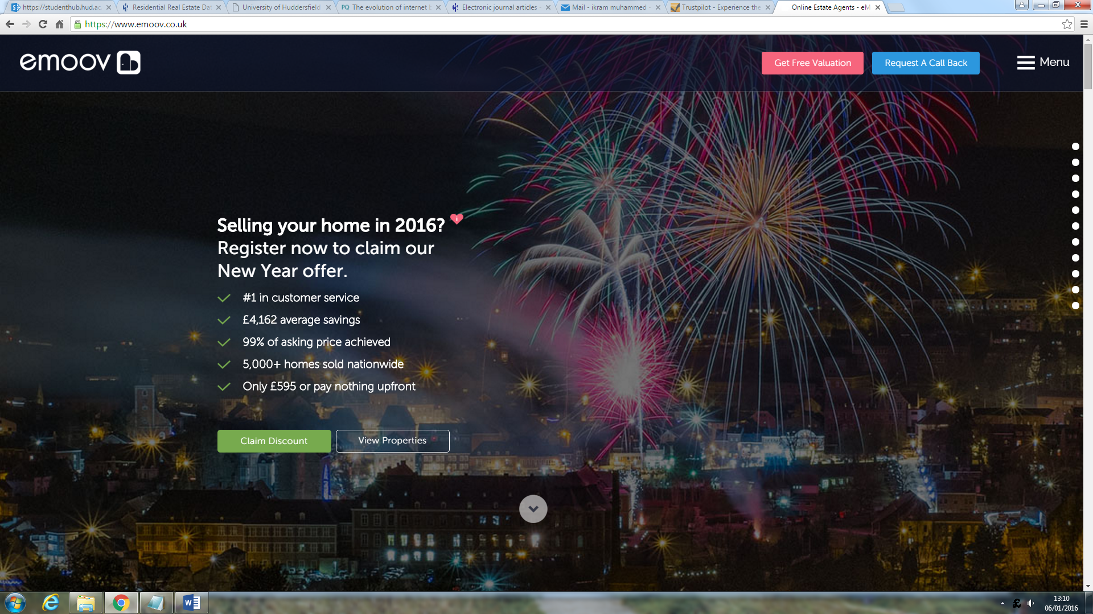

Emoove.co.uk is a well-established online estate agency that specifically on selling houses. Although the website allows users to buy and sell property but it is designed more specifically for property sellers. We know this from their home page because the first thing we see on their home page ‘selling home in 2016’.

**Content:** In terms of content, the website does include all the information that we would expect to see on the estate agent website. We can navigation to information such as selling house, searching for property, how it works and company reviews.

**Links**: The website has numbers of links that link to pages across website and external websites. The main set of links is navigation bar on the side of the pages, which allows users to go main pages such as ‘sell my home’ page.

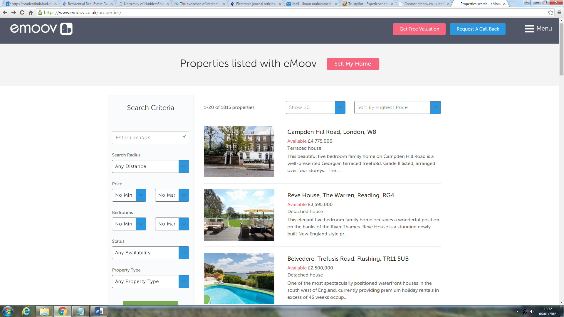

**Search facility:** Although the website has a search function that allows users to search for properties however, the search function is hidden and hard to find. In today modern websites, it is essential to have a clear search function that can be easily found.

There are various search criteria’s such as price, property type, location etc.… which user can be used by customer to narrow down the search and find his required property.

**Registration:** The website have register and login function which perhaps allows user to monitor their everyday activities with company. However, it first requires choosing the package first. User will not be able to register with company unless he buys a package first.

The company has providing excellent customer service and delivering to their potential. According to TrustPilot.com company has gained number of positive feedback compare to few negatives. However, most of the positive feedback have come from them been good seller rather than buyer and seller.



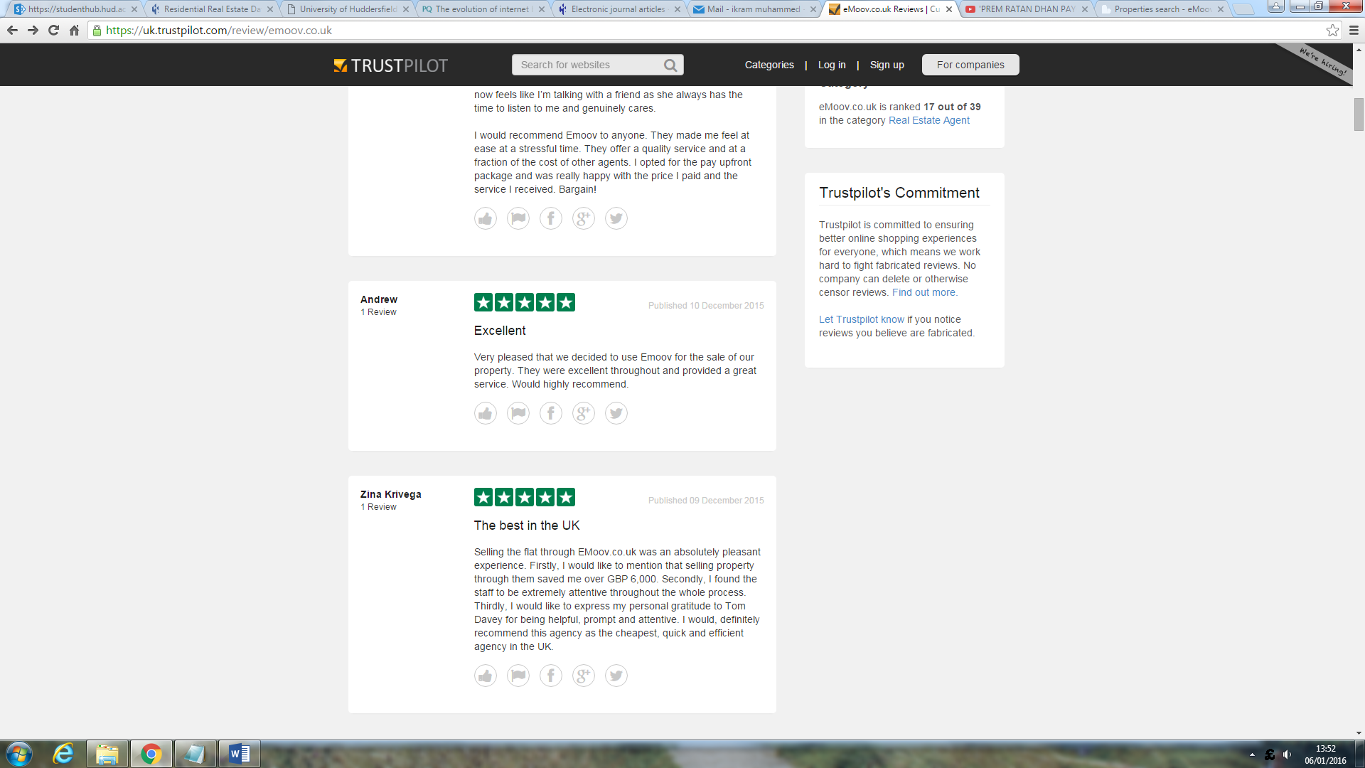

### 2.7.3 Spareroom.co.uk

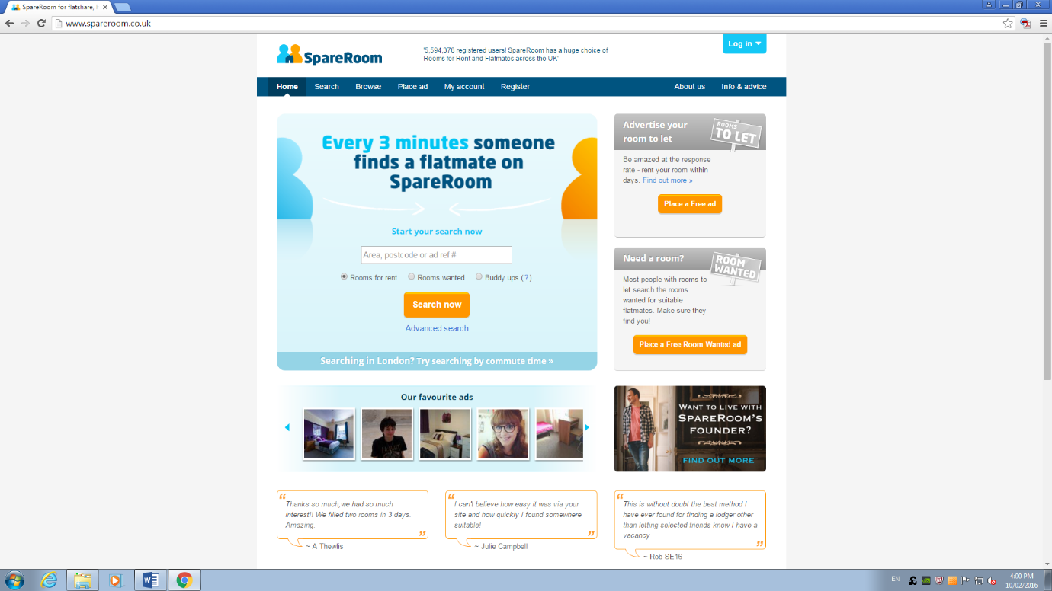

Spareroom.co.uk is the UK most comprehensive flatshare website which claims someone find a flat mate with them every 3 minutes. The home page of the website is very clear and has combined graphics and texts.

The website has a similar idea to mine. It allows people to find and rent rooms where as mine will include find or rent room as well as buy and sell property.

On the home page, it got a form where it ask user to specify the area they want room in. once user inputs the area, the search result shows the rooms based in user required area.

What I like about this website is, it allows users to rent room for free. Users clicks on ‘place ad’ link in the navigation bar. The website will than allow them to add room in their system for free.

According to TrustPilot.com the website has a brilliant feedback from customer. They provide excellent customer service and always reply to their bad feedback. Although company received few negative back however, they took the feedback into account and replied to user who was not happy with the service.

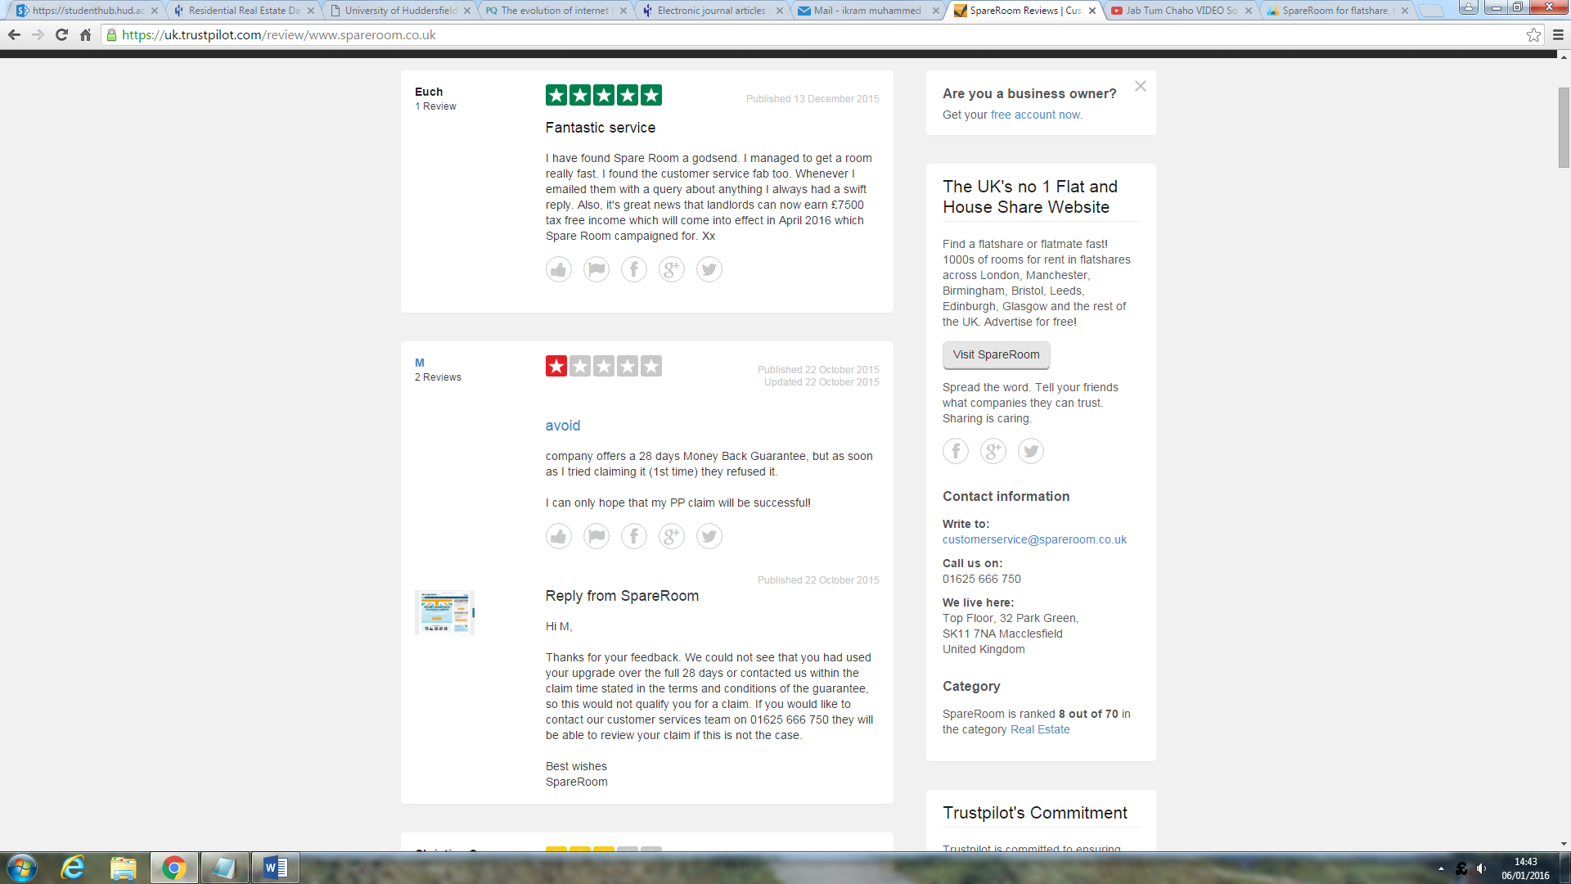

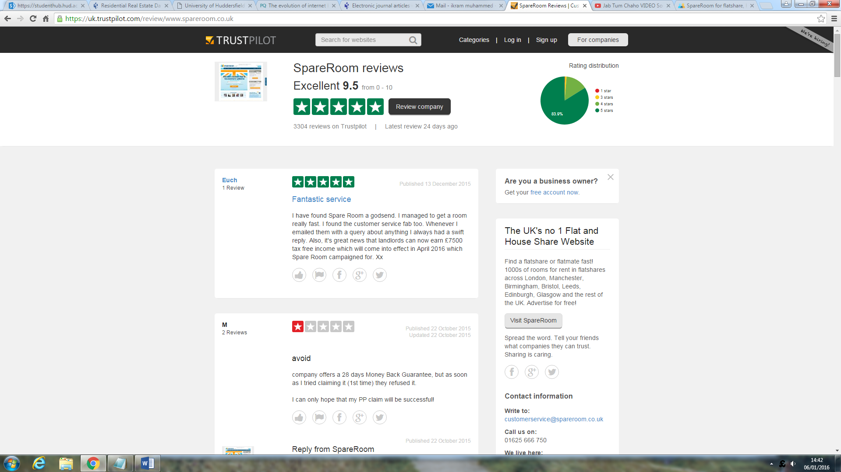

### **2.7.4** Existing online estate agent comparisons.

Below is the table showing comparison between the popular online estate agent agencies.

|  |  |  |  |  |
| --- | --- | --- | --- | --- |
|  | http://img01.thedrum.com/s3fs-public/drum_basic_article/105625/main_images/Z_0.jpg | http://static.allagents.co.uk/pictures/logos/profile/2015072308352502722.jpg | http://www.proactiveinvestors.co.uk/thumbs/upload/Company/Logo/2015_12/150x88_pur1.png | https://images2.spareroom.co.uk/img/logos/SpareRoom_en-GB.png |
| Overall  (Trustpilot.com) | Poor 4.7 | Excellent 9.1 | Excellent 9.4 | Excellent 9.5 |
| Services comparison | | | | |
| Audience | Zoopla is specifically targeting customer who are buying properties and people seeking property information. | Although Emoove target market is buyers and sellers buy their main focus is people who are looking to sell property. | Purplebricks also specifically focuses on property sellers rather than property buyers. | Spareroom is targeting everyone who is willing to find a room or let a room. |
| Packages | Zoopla is a property portal, providing details of homes listed for sale/to buy by estate agents. | Emoove provides number of packages:  • Floor plans and photographs  • 'For sale' board  • Listing on Zoopla and Rightmove  • Viewing bookings  • Offer negotiation | Purplebricks packages includes:  • Floor plans and  photographs  • Listing on Zoopla and Rightmove  • Viewing bookings  • Offer negotiation  • Sales progression | Services provided by Spareroom are:  • Rooms ads  • Room browsing  • Info and advice  • My account to manage to everyday activities |
| Extras |  | • Premium listings  • Virtual tour  • EPC  • Personal account manager  • Conveyancing | • Premium listings  • EPC  • Property brochure  • Accompanied viewings  • Conveyancing  • Mortgage broking |  |
| Free | Free | £594 or £1,194 | £798 or £1,158 | Free |
| Design & layout | | | | |
| Ease of use | 8 / 10  Website is easier to use. The information can be clearly seen. | 7 /10  Website is highly interactive. For some people it can be problematic to use it. | 8 /10  The website is easy to use. All the function can be seen clearly. Easier to find information. | 8 /10  Easier to understand the purpose of the website. Easier to find rooms and find information about them. |
| Navigation | Clear navigation bar on top of the page, linking to useful pages. | Navigation bar is on side. Due to high interactivity, hard to understand and use navigation bar. | Clear navigation bar on top of the page linking to services. | Simple and user friendly navigation bar on top of the page. |
| Structure & Presentation | Website has excellent structure. All information is well presented. | Website has a scroll structure on home page. User have to scroll a lot. | Similarity like Emoove, the home page has a scroll structure where user have to scroll a lot. | Well-presented website. But it’s in centre on the page. |
| Responsive | No | Yes | Yes | No |

### **2.7.5 Understanding the current problem**

Although, research into existing platforms has been done in above section however in order make user requirements more clearly, further techniques are been used; they are:

* **Heuristic analysis**
* **Personas**

#### **2.7.5.1 Heuristic Analysis**

“Heuristic evaluation involves having a small set of evaluators examine the interface and judge its compliance with recognized usability principles” (Ghanaian, A.G, 2014).

|  |  |  |  |
| --- | --- | --- | --- |
| *Platform* | *Problem* | *Evidence* | *Recommendation* |
| http://img01.thedrum.com/s3fs-public/drum_basic_article/105625/main_images/Z_0.jpg | The information on search result page is not clear. Search result page contains a lot information that makes website look messy. |  | New platform will have improved design and layout throughout the application. Unwanted information will be avoided and only important information will go on pages. |
| http://img01.thedrum.com/s3fs-public/drum_basic_article/105625/main_images/Z_0.jpg | In order get more properties details, user will have to contact property seller estate agent. The process may take long time and cause delays. |  | New platform will be more efficient. The property information will be sent to user soon the request will be made. |
| http://static.allagents.co.uk/pictures/logos/profile/2015072308352502722.jpg | The home page of emoove.co.uk is aiming at sellers only. Although it’s for buyers and sellers however, the design is focused on only sellers. |  | The layout and design of new platform will be focused on buyers and sellers. It will be clear and straight to point. User will with buy or sell from the home page. |
| http://static.allagents.co.uk/pictures/logos/profile/2015072308352502722.jpg | The navigation bar on the emmove.co.uk is not user friendly. User is required to do a lot of scrolling. The background colour makes it hard to see. |  | The navigation on new website will be horizontal. It will have mixture of simple and bright colours to make it look professional. It will be on top of the page; allowing users easier to navigate. |
| http://static.allagents.co.uk/pictures/logos/profile/2015072308352502722.jpg | When it comes to do property search, user will have to click ‘Menu’ than ‘properties’. It is difficult to find property search page as ‘properties’ could just mean anything else. A better term such as ‘browse properties’ would be more helpful. |  | On new website the property search from will be on first page so user don’t have to find the page. It will make website look friendlier and have the balance between property buying and selling. |
| **More heuristic analysis are explained in appendix 7.2** | | | |

#### **2.7.5.2 Personas**

Personas are useful to create reliable and realistic representation of key audience. They would take real world consideration into account help us to find user needs. Here some personas based on people from different stages in their lives.

|  |  |
| --- | --- |
| Name | Jack Timblin |
| Age | 27 |
| Profession | Web Programmer |
| Description | Jack is talented young programmer; graduated from Huddersfield university in 2013 now works for company called Charterpoint. Jack is originally from London but he relocated because of his job. Jack owned a 2 bedroom house in London which worth £190,000. Jack sold his house when he relocated at Manchester. He sold his house through estate agent and paid them around £3000.  Jack looked on internet for alternative ways to sell home. He came across a platform called ‘eMoove’ but they would also chare him £1500. Jack also found their website confusing to use further research suggested their customer service is week. |
| Needs | Jack wishes if there was a cheap and quick way to sell his house. He was looking for a website that is cleanly designed and provide excellent customer service. |

|  |  |
| --- | --- |
| Name | Chris Grantham |
| Age | 55 |
| Profession | CEO of Charterpoint |
| Description | Chris runs a company called Charterpoint. Chris is educated and organised individual. He always lived in Manchester. Christ has been through the process of buying and selling home. When Chris sold his house last time, he contacted his estate agent. Estate agent put the ad of Chris house on their windows and on ‘*Zoopla.com’* website. Chris decided to edit his ad on ‘*Zoopla.com’* but was not able to do so. He had to go back to estate agent in order to edit his property. This process took further time and money. |
| Needs | Chris needs a platform where he can put an ad of his property by himself. That platform than allow Chris to edit his Ad if there is any change to make. He don’t want to go to estate agent over and over again. |

|  |  |
| --- | --- |
| Name | Mufasar Ali |
| Age | 21 |
| Profession | Student |
| Description | Mufasar is a bright student at the University of Huddersfield. He as great commitments towards his studies and looking forward to go into IT support once graduated. Mufasar is originally from Halifax but due to studies he moved to Huddersfield.  Mufasar currently lives in one room which he found on website called ‘*spareroom.com’.* Mufasar found the website very useful and fit for purpose. Once he will graduate, he will use the same website to sell the room as it also allows user to sell rooms. |
| Needs | Mufasar found this website great. However, he wishes if there was a similar platform around that would allow him to just to buy and sell room but also buy or rent properties. The platform have same concept of ‘spareroom.com’ and provide wide range of services. |

## **2.8 Research into tools and skills required**

In this section, the discussion of the tools and skills that are required to complete this project will occur. It is important to carry out good research in order to identify and select the most effect tools in order to complete this project. A wrong tool selection will not only create problems in development process but it will also have an impact on overall project.

### 2.8.1 Integrated Development environment (IDE)

Development environment refers to the set of processes and programming tools used to create the website or any other software application. This project is just not a simple website; it’s quite a big website with a lot of functionalities. Therefore it will require the right development environment.

**Linux vs Windows**

The first thing is to decide which operating system I should use in this project. The two most common operating system used in web development are Linux and Windows. Both operating system offers different functions to assist developers to develop website.

Linux is free and very easy to install. Most programmers tend to use command line interface such as Vim or Emacs for programming so Linux would be helpful to them. Although this operating system is open source but it’s also very secure. Which enables business to run their servers using Linux operating system. Support to install and learn is also available on [*http://www.ubuntu.com/*](http://www.ubuntu.com/) which makes this system effective to learn and use.

Windows operating system are not free. They cost around $99 to $300. Although Microsoft are always looking to improve the security of operating system and utilizing different ways to make it more secure however windows still continues to be the most vulnerable to viruses. Windows are not open source, meaning it is difficult to customize and modify the code.

### 2.8.2 Programming Languages

Choosing a right programming language is vital part of this project. There are various factors I must consider before choosing the right language for this project. The project will involve front-end development and back-end development therefore I will need to insure I make a right language selection.

***Front-end language***

Front-end also refers to client side development which refers to the pages what users see and interact with. Front is vital requirement for this project. The following technologies are common to develop front-end of the website.

*HTML & CSS:*

HTML stands for Hyper Text Mark-up Language which is used for structuring and presenting content on the word wide web. Whereas CSS stands for cascading style sheet which is used to apply styling and colour to the content on web pages. One of the advantage of this language is that it’s easy to learn and use. It’s free and finally it’s the most common language used to display the content on web pages.

*JavaScript:*

JavaScript is a scripting language that is used to add interactivity to the content on the web pages. Developers use this language to make content highly interactive that’s appeals to user. The advantage of this scripting language is it’s easy to learn and use. A lot of support is available on internet for help. JavaScript is also work effectively with JQuery.

***Back-end***

Back-end of the website makes front-end possible. A user may fill a form, or place an order or browse for product; all this is possible because of back-end. Here are some of the popular backend programming languages.

*PHP:*

PHP is one of the most common server side programming language. You just need three things to make this work. The PHP parser, a web server and web browser. One of the advantage of PHP is that it be used on all major operating systems including Linux. The language also supports most of the servers including Apache and Nginx. PHP support wide range of databases. Writing a database- embedded webpage is really simple to do in webpage. PHP also support for talking to other services such as LDAP, IMAP, SNMP and HTTP.

PHP languages also has many frameworks which use the MVC structure. Three of most common PHP framework are called Phalcon, Codelgniter and Laravel.

* *Phalcon (PHP framework):*

Phalcon is an open source, full stack framework for PHP 5 written as a C-extension, optimized for high performance. You don't need learn or use the C language, since the functionality is exposed as PHP classes ready for you to use. Phalcon also is loosely coupled, allowing you to use its objects as glue components based on the needs of your application. It is really easy to learn and understand Phalcon as documentation on Phalcon website are very well prepared. Phalcon can be downloaded and installed from GitHub; <https://github.com/phalcon/cphalcon>.

* *Codelgniter (PHP Framework):*

Codelgniter is another powerful PHP framework. It has a very small footprint. One of the advantage of this framework is it doesn’t require template language. It also is compatible with all PHP upgrades and supports all common database application including MYSQL. The framework is easy to install and run; just require few amendments into config page.

* *Laravel (PHP framework):*

Laravel is another free, open-source PHP framework based on MVC structure. It comes with various features that are different from other frameworks such as packaging system with dedicated dependency manager and different ways for to connect with accessing databases. The Laravel can also be downloaded and installed from GitHub; [*https://github.com/laravel/larave*](https://github.com/laravel/larave)*.*

*Python:*

Python is another popular server side language it’s free and easy to learn and use. Python very closely resembles the English language, using words like ‘not’ and ‘in’ to make it easier for you to understand and code. A lot of Python code is built up over decades, been an open source code. All of this code can be found on[*https://pypi.python.org*](https://pypi.python.org).

### 2.8.3 Version Control

Even though this is not a vital requirement for part of this project, having this product under a form of version control not only acts as a back-up, but it also acts as a constantly evolving log each time a commit is made. The two main Version Control applications available are Subversion and Git. Both of these version control systems allow you to commit work and update the code base and also leave a message to what has been changed, however Git has some major advantages over Subversion.

* *Branching & Merging*

Branching and Merging in Git is the feature that makes it stand apart from the rest. It allows you to be able to develop a new idea away from the main code base, and be able to commit it for other contributors to work on and if the idea works it can be merged into the main branch, or you can go to the existing branch. This is good when developing experimental code onto of a tested code-base and reduces the risk of damaging the whole application’s code-base.

* *Staging Area*

Git is the only source control manager that has what is known as the “staging area”. This is the area commits are initially sent to so that all of the commits made can be reviewed before they are permanently committed to the repository.

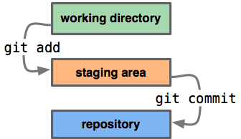

Figure 3: CodeWizard, (2016).

* *Online Repositories*

There are also repositories that can be hosted on-line such as GitHub *(*[*https://github .com/)*](https://github.com/) and BitBucket ([*https://bitbucket.org/)*](https://bitbucket.org/). These are invaluable because they allow the community to work on projects from anywhere in the world. These repositories are also good for projects like this as they have the functionality to allow private repositories. Having a repository on-line not only allows me to work from anywhere, it also acts as a on-line back-up and log of the work that I have done.

# **3- Requirements Specification**

The explanation and justification of the choices of tools and software programmes that will be used in order to complete this project will be explained in this section as well as the user requirements.

## **3.1 User and system requirements**

The aim of this project is to build an online estate agency platform that just not has new features but also combines all the technologies form existing platforms. For clarity purpose, user requirements are separated in 2 ways:

* Functional requirements
* Non-functional requirements

The prioritization of user requirements would also be key here. It is important to ensure the user requirements are prioritized as it will not just help me to identify the important function of the product but also it will assist me in product evolution. Therefore, MoSCoW method has been used to prioritize the user requirements.

### 3.1.1 Functional requirements

|  |
| --- |
| No: 1 Priority: Must have Method found by: Literature review |
| Application must allow users to sign up and create account |

* 1. Application would have standard form that requires user to enter their name, email, and password and confirm password.
  2. Application will ensure the new account created doesn’t already exist in system.
  3. Application will ensure all the fields are completed and the data is in correct form before adding an entry in database.

|  |
| --- |
| No: 2 Priority: Must have Method found by: Literature review |
| Website to allow users to add property into system |

* 1. The form requiring users to give property details such as address and type.
  2. The form requiring users to give is property description.
  3. Form requiring users to give property images.
  4. The application will check if property already exist in the system.
  5. The application will display an alert confirming the form submission
  6. Website saving the property details and displaying a approve request on admin page.

|  |
| --- |
| No: 3 Priority: Must have Method found by: Literature review |
| Website should allow user to edit their properties details if they need to. |

* 1. The application must allow user to edit their own property.
  2. When user will click ‘edit’, the application would display the form to edit the property.
  3. The form should already display the existing property details, allowing users just to amend the existing details.
  4. Application will check for validation and correct information.
  5. User will be a shown a message; property details been updated.

|  |
| --- |
| No: 4 Priority: Must have Method found by: Literature review |
| Website also should allow user to remove their property ad form website |

* 1. Application is also to allow user to remove their property themselves.
  2. Application to display remove button next to user property; when clicked it should remove property.
  3. Application to display confirmation message once the property is deleted.
  4. Application must remove record from database once the property is deleted.

|  |
| --- |
| No: 5 Priority: Must have Method found by: Literature review |
| Website must have a form on home page allowing users to search for properties. |

* 1. Application to have a search form on the home page; allowing user to browse properties.
  2. The standard form must have an search options of ‘Town, ‘Property type, ‘Price’ and ‘No of bedrooms’
  3. The form must ask user to complete at least one field.
  4. If no results are found, application should display message saying no results are been found.
  5. If results are found, application must take user to search results page.

|  |
| --- |
| No: 6 Priority: Must have Method found by: Literature review |
| Users should be able to contact sellers through email. |

* 1. Application must display ‘contact seller’ button on the property details page.
  2. When clicked, application must show standard form; asking user details.
  3. Application must apply form validation; ensuring fields are completed.
  4. Application must send email to the property seller.
  5. Application must show confirmation message; email been sent.

|  |
| --- |
| No: 7 Priority: Must have Method found by: Literature review |
| Admin should also be able to add property in system |

* 1. Website also should allow admin to add property in system.
  2. It to have a standard form; requiring all possible property details.
  3. Before submission, website must apply validation; ensuring the data is correct.
  4. Website saving the property details and displaying a approve request on admin page.

|  |
| --- |
| No: 8 Priority: Must have Method found by: Literature review |
| Application to display all the request for properties approval |

* 1. Application must display all the properties that needs approval by administrator with ‘approve’ button next to it.
  2. When clicked on ‘approve’ application must display a standard form with properties details.
  3. Application must apply validation to form before it goes in system.
  4. Application must make the property ad live in system.
  5. Application should display confirmation message; property been approved.

|  |
| --- |
| No: 9 Priority: Must have Method found by: Literature review |
| Application to display all the valuation requests received |

* 1. Website should display all the requests received for the property valuation
  2. When click on add ‘add price’ website to show a model to allowing admin to a add price.

|  |
| --- |
| No: 10 Priority: Should have Method found by: Literature review |
| Application should allow user to update their profile once they will be registered. |

* 1. Once user will have an account, application will allow them to update their details.
  2. Once user will logged in, they should be able to click ‘update details’ button.
  3. The form on edit details page would already display the correct details so user will just amend those details.

|  |
| --- |
| No: 11 Priority: Should have Method found by: Literature review |
| The application should allow user to manage their everyday activities. |

* 1. The application will have navigation bar at the top, allowing users to manage various aspect of their accounts.
  2. The application will allow user to see what ad’s they have currently going.
  3. The website will enable users to view their favourite properties.
  4. The website would allow users to add property to sell.

|  |
| --- |
| No: 12 Priority: Should have Method found by: Literature review |
| There should be another form on search result page; allowing users to refine search. |

* 1. Application must show another form one the search page.
  2. Form should allow user to update their search.
  3. Form could show the existing options user picked from the home page.

|  |
| --- |
| No: 13 Priority: Should have Method found by: Literature review |
| Users should be able to add property into favourites. |

* 1. Application must display ‘Add to favourite’ button on the property details page.
  2. When clicked, application must first check if user is logged in.
  3. If user is logged in, application must add property into user favourite.
  4. Application should display confirmation message; property been added to favourite.
  5. Application should also allow user to remove property form their favourite.

|  |
| --- |
| No: 14 Priority: Should have Method found by: Literature review |
| Application to allow admin to publish blog |

* 1. Application must have a form, allowing admin to fill in blog content. Application must ensure all required fields are completed.
  2. Application must save the blog in system and print confirmation message.
  3. Application must display the blogs on blog page.

|  |
| --- |
| No: 15 Priority: Could have Method found by: Literature review |
| Application could allow users to email properties details to friends. |

* 1. Property details page could have button saying ‘share with friends.’
  2. Standard HTML form could appear when user click the button.
  3. User would complete the from fields such as name and friend email.
  4. Application could grab the friends email from form and send the property details to that email address.

|  |
| --- |
| No: 16 Priority: Could have Method found by: Literature review |
| Application could have separate property valuation form on new page. |

* 1. In navigation bar, application could have valuation button which would link to valuation page.
  2. On click, website open valuation page with standard HTML form for property details.
  3. On form submit, the form should save the input in database.
  4. Print confirmation message; valuation request been received.

|  |
| --- |
| No: 17 Priority: Won’t have Method found by: Literature review |
| Develop an API to connect with Zoopla.com to publish properties on Zoopla. |

* 1. I won’t develop a function that will interact with Zoopla API for properties advertising purpose.
  2. I won’t obtain any information from Zoopla or any other existing platform.

### Non-functional requirements

|  |
| --- |
| No: 19 Priority: Must have Method found by: Literature review |
| Existing website such as emoove.com and purplebricks.com only targeting sellers. |

* 1. Application must target buyers and sellers.
  2. The design and layout must be balanced between buyers and sellers.
  3. Graphics on home page must be targeted at buyers and sellers.

|  |
| --- |
| No: 20 Priority: Must have Method found by: Literature review |
| Clean and easier to use navigation bar. |

* 1. Application must have horizontal navigation bar; which is easier to use.
  2. Content should be clear on navigation bar
  3. Button links must work and link to correct pages.
  4. Navigation bar must be responsive.

|  |
| --- |
| No: 21 Priority: Must have Method found by: Literature review |
| Better property search form |

* 1. New website must have a clear and consistent form.
  2. It should display important search criteria’s for user to use.
  3. Input fields and buttons must be large; easier to use.
  4. Must have some validation

|  |
| --- |
| No: 22 Priority: Must have Method found by: Literature review |
| Supported database structure. |

* 1. Application must have supported database to store all the information such as properties and members.
  2. Database must consist of many tables; each different set of information should be saved in different table.
  3. Database must have a connection with application at all times.

|  |
| --- |
| No: 23 Priority: Should have Method found by: Literature review |
| Application should be backed up at all times. |

* 1. Application should be backed-up at all times to recovery purpose.
  2. Application should be backed-up in more than one place.
  3. Application should also be backed-up in online repository.

|  |
| --- |
| No: 24 Priority: Should have Method found by: Literature review |
| Data privacy |

* 1. Application should ensure all the data passed from customer are well protected.
  2. Date protection act (1998) should be utilized.

|  |
| --- |
| No: 25 Priority: Should have Method found by: Literature review |
| Scalability |

* 1. Website should be able to use by many users at once without any drop in speed.
  2. Data should be processed effectively for each individual.

|  |
| --- |
| No: 26 Priority: Could have Method found by: Literature review |
| Availability |

* 1. Website could be hosted live and be available for everyone.
  2. Host and domain could be set up to host the website.
  3. Research could be done to find cheaper web domain to host website.

|  |
| --- |
| No: 27 Priority: Won’t be Method found by: Literature review |
| Inconsistent |

* 1. Website won’t be inconsistent
  2. Design and layout won’t be different on different pages.

# **4- Project planning**

## **4.1 Development methodology**

Choosing a right development methodology to use in the project is essential for overall success. From research, there are two suitable methodologies that we can use in the development of this project; Waterfall and Agile methodology.

### 4.1.1 Waterfall Methodology

Waterfall is linear approach to software development; containing sequences of events which are shown in figure below. In traditional waterfall methods, there are different stages representing a step in software development. Develop user must finish a stage before he moves into next stage for example design stage much be completed before moving on to development stage (Lotz, M.L, 2013).

Winston Royce (1970) argued ‘Analysis’ and ‘Coding’ are two most essential in program development regardless of its size or complexity. The traditional waterfall does not focuses on these essential stages. Therefore Winston Royce (1970) re—modelled the traditional waterfall model. He added more steps ‘software requirements’ and ‘program design’.

However, the inclusion of extra steps did not solved the problem of going back to step.

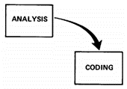

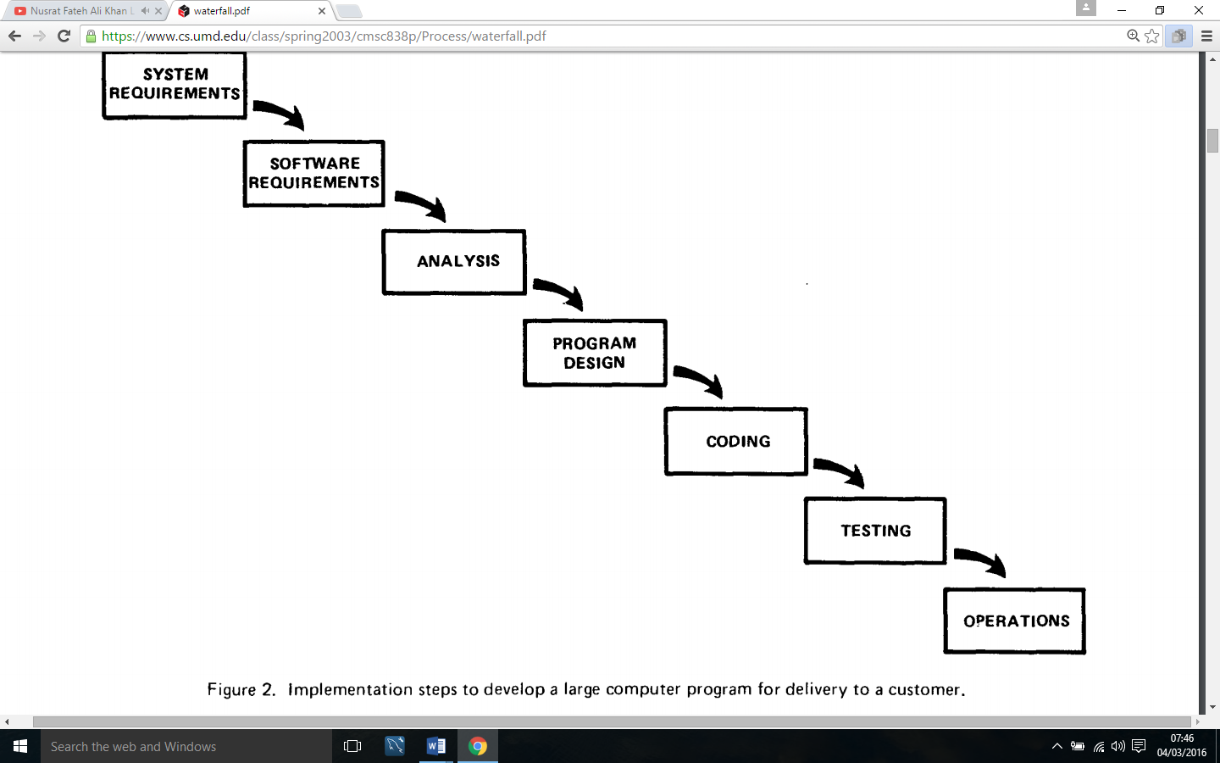

Figure 4: Waterfall Model Royce, W.R. (1970).

Figure 5: Waterfall Model Royce, W.R. (1970).

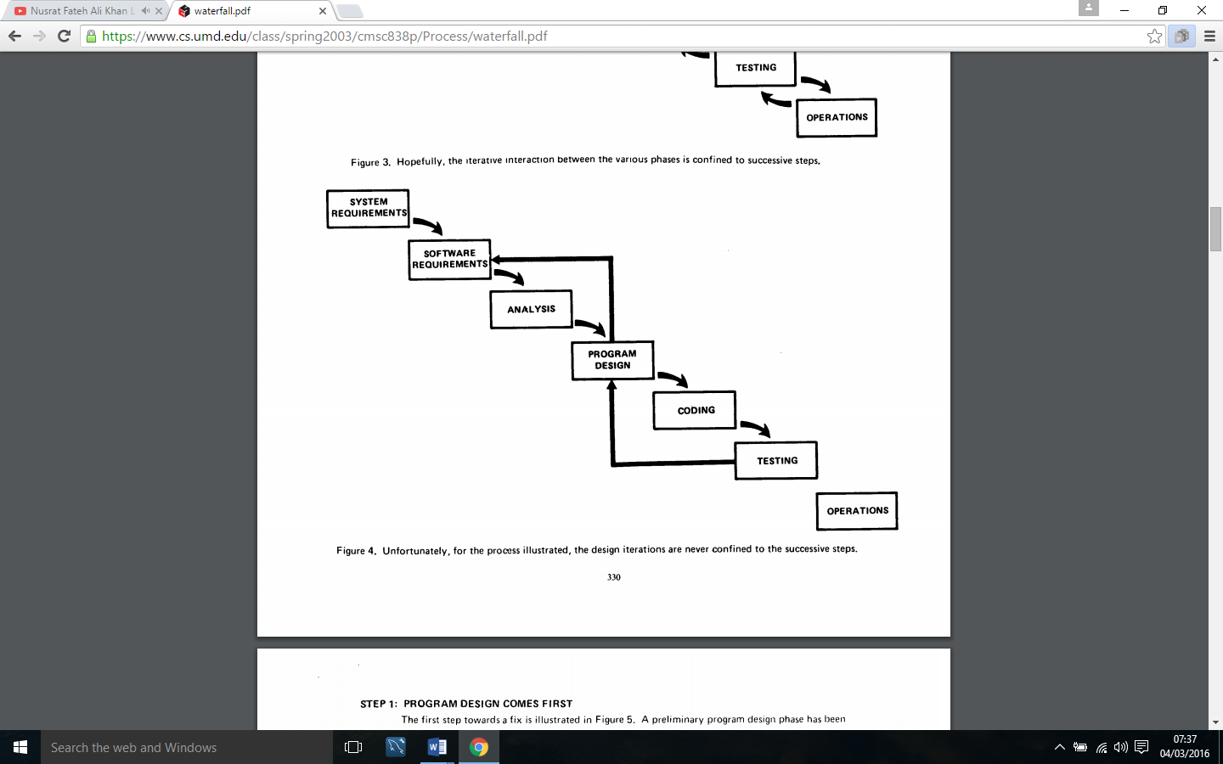

Figure 6: Royce, W.R. (1970). Waterfall Model

The improved model by Winston Royce (1970) enables develops to go back to the ‘program design’ and ‘software requirements’ irritation in able to make any changes to project. Royce (1970) believes traditional and linear approach is more risky. In this new approach; develop is able to go back to specification and design cycle; thus it deuced the risk of project failure.

One advantages of using this method is customers and developers discuss the requirements at the start of lifecycle; therefore once requirements are done, customer presence is not required (Lotz, M.L, 2013). The design is captured before the software is written; saves time during the implementations stage. And finally this method has structured approach therefore its easier to measure the progress of product and help developer plan further.

### 4.1.2 Agile Methodology

Agile method is “subset of iterative and evolutionary method” used in software development in order to respond to unpredictability (Williams L.W, 2007). This method highlights the rapid delivery pf project and gives opportunities to assess the direction of the project throughout the development lifecycle.

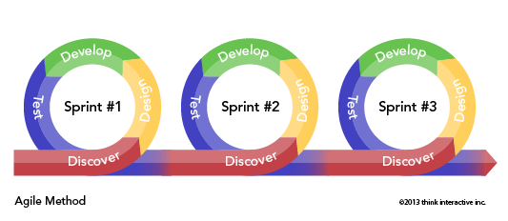

This method allows developers to keep looking back at their work and improving it throughout the development. Once the stage is completed; developer is able to re-design and develop; ensuring it’s meeting customer requirements.

This method is more modern compare to waterfall method therefore it has more advantages than waterfall. One of the advantage; it has customer presence meaning customer will ability to see the work and test it; and make further decisions. Another advantage of this method is developer is more user focused, they are keep improving the work meaning the overall product will exceed user requirements (Lotz, M.L, 2013). And finally, it allows develop to respond to user quickly which can lead to time and cost reduction.

The method however actually may be slower compare to waterfall as develop has to keep going back to previous stages. This may lead to further cost increase and time consumption. Another issue with method is it requires a lot of dedication and commitment from developers as they will be working closely with customers. Therefore the relationship with customer also will play a role in this method (Lotz, M.L, 2013).

### 4.1.3 Method chosen

After looking at the two different types of methodologies, the conclusion that has established is that in this project the best method would be *improved* *waterfall methodology*. Obviously, we haven’t got specific time frame for each of the stage in this project however we got a sloid idea of what we are wanting to achieve through the development process. Thus, we can effectively build this product in linear fashion as requirements identified in section 2 are not likely to change.

Another reason of choosing this project is that they will be no clients involved in this project. Requirements will be collected and analysed, then design will be established based upon requirements and product will be built. So this project is straightforward therefore simple and traditional method will be more useful.

Finally, this new waterfall model will enable me to go back to my ‘specification’ and ‘design’ steps so I improve them. This will help me to ensure the project has correct requirements and design is based on those requirements.

The only advantage that can be seen in using agile method is that it would allow us keep looking back at each iteration and improving it. But because this project is not big and complex, we will be able to go back to previous stage and improve it using waterfall method.

## **4.2 Justification of the chosen tools and software’s**

## 

**Programming language**

Over the past 3 years I have experienced various programming languages in various projects. For this project, I have to choose the one I know the most. The choice I decided to make is ‘PHP’ simply because I have the most experience using this language during my university studies and placement industry.

Another reason for choosing this language is because it’s very easy language to execute regardless of what platform it is running on, so this automatically my product platform independent.

PHP language has various frameworks that promotes MVC structure. I have experienced using two common frameworks called Phalcon and Codelgniter. I used Codelgniter during of second year of university. Whereas I used Phalcon throughout my placement year in web development industry.

I have decided to choose Phalcon framework in my project because I have good one year experience using it. I have learnt it from scratch to advance levels therefore I believe it will be easier for me to use this framework. I have not chosen Codelgniter because I only used it for around 3 months. My skill level of Codelgniter is not high therefore I believe If I use this framework, I will struggle during the development of project.

I have not chosen Python because I have never used it therefore I didn’t wanted to take a risk of using it and failing to complete this project.

**Operating system**

I have used two most common operating system that are developers friendly; Windows and Linux. I have used both these operating software’s to complete various development projects during university and placement. The operating system I have decided to use for this project is Linux. I have chosen Linux because I used Linux over the placement year while working at Charterpoint ltd and my research in above section shows Linux is more for developers whereas Windows is more general purpose. The other reason I choose Linux is because I will me using command line interface which I have done in Linux many times.

I will not Use Windows simply because I have never experienced using command line interface in Windows which is a requirement for this project. However, I will use Windows to carry out other general project activities such as writing reports and drawing time management.

**Virtual box**

I will be using Oracle Virtual box to make my products useable on various platforms. Linux will operated using Virtual box so I can do testing on Windows during the development box. The variant of Linux that will be used is Ubuntu which is will be available at [*http://www.ubuntu.com/*](http://www.ubuntu.com/)*.*

**Vision Control**

Having project backed-up is essential. A Git vision control system will be used to backup this project. The project will be stored on-line in a private repository which will act as back-up of project code. The repository can be accessed from any location. Git control system will produce a log of all the changes during development which will be attached to the appendix after completion.

**MySQL workbench**

Another essential software that will be require is MySQL workbench. This will be used as creating and managing database tables. The software will have a connection with the website so information submitted through website can be analysed in MySQL workbench. It will also be used as analysing data and generating SQL queries. The software will be downloaded free from <http://www.mysql.com/>*.*

I could have used PHP myAdmin however, I have more experience using MYSQL Workbench therefore I choose MYSQL workbench to use for this particular project.

**SourceTree**

Although SourceTree is not an essential for this project, however it will be used to make life easy when interacting with Git repositories. Using Linux command line for Git can be confusing therefore SourceTree will be used to Push and Pull work of online repositories.

***MS Project***

Planning will be essential in this project epically in development. Ms Project will be used to produce the Gantt chart for the project. All the activities will be shown along with the time. The Gantt chart will be used to manage time well, plan ahead, ensure the activity is completed before moving on to new activity. This software is available in university and cost nothing.

***Miscellaneous tools***

Some further miscellaneous tools will be used during this project. For example, MS Visio studio will be used to carry out UML designing of use case and sequence diagrams. MS PowerPoint will be used to do the prototyping of the product.

## **4.3 Project risks**

It is essential for us to have a look at what could be the risk associated with this project. Having risks monitored prior to development stage will give us an opportunity to come up with some action plans which we may utilize when an unexpected event occurs.

For clarity purpose, it is been decided to separate the risks according to the waterfall methodology stages; so know what stage has most risks associated.

|  |  |  |  |  |  |
| --- | --- | --- | --- | --- | --- |
|  | **Risk** | **Probability**  **( L,M,H)** | **Impact**  **(L,M,H)** | **Effect on Project** | **Risk Reduction Actions** |
| **Requirements** | Having not understood the requirement may lead to building wrong product/function. | L | H | In this case, existing property websites must be analysed fully. If not, the new platform will be exactly the same as some already in market. There will be no difference. Which may lead to failing to achieve aims of this project. | Risk can be reduced by spending sufficient time on analysing existing property websites. This can be done by looking at website features such as login, search and contact etc.… |
| Requirements change during the course of project | L | M | This risk is very less likely to occur. All the requirements will be collected prior to development stage. During the development stage; focus will be converting requirements into solution. | Although this risk is less likely to occur. However, it can be minimized by ensuring all requirements are fully defined prior to development stage. |
| **Design** | Skill level of modelling | L | M | The design phase of project involves creating modelling diagram such as use case diagrams. Because it been a while ago since I did some work on modelling, therefore there is a potential risk for getting modelling wrong. Creating wrong diagrams may effect on development. | Risk can be minimized through doing some modelling practising prior to actually creating design. |
| Understanding of Bootstrap | M | H | The new platform will be based upon bootstrap. Even after having one year experience in using bootstrap; there are some elements that are not been touched therefore there is risk presence. | This risk can be reduced by doing further research on bootstrap. This can be done through watching you Tube videos, going through documentation and online examples. |
| **Development** | Understanding of Phalcon (PHP framework) | M | H | Even though it is been decided to use PHP Phalcon to build this product but my skill in this language is advanced. This could messnojan I may face some issues building the product. | Having good relationship with supervisor from placement will be useful here. If not sue about anything or can’t get something to work, help can be sleeked from placement supervisor. |
| Linux sever configuration | M | H | Virtual machine and Linux development environment will be used in project. The key assigned to virtual machine some time does not work therefore there is potential risk of virtual machine not working here. | The risk can be minimized by backing up the virtual machine ID so in case if it doesn’t start; ID can be used manually to start machine. |
|  | **More project risks are highlighted in appendix 7.2** | | | | |

## **4.4 Project time management**

An overview of the project time plan is already been discussed in section 1.3 but it only looks at weekly overview. In this section, we will go into a bit more detailed project plan.

Gantt chart will go here

## **4.5 Modelling**

Before going into the initial design of the website; it will would be useful creating some use case and class diagrams which will show the main function of the website.

### 4.5.1 Use case diagrams

1. **Use case diagram showing user adding property ad into system.**

This use case diagram shows how a user would add a property. Diagram allows us to see how the adding property function will work. 

1. **Use case diagram showing user browsing for property.**

Following use diagram shows how application would allow user to browse properties. It highlights what could be the key elements user could use to preform search results.



1. **Use case diagram showing user editing property.**

Follow using case shows what existing properties website don’t have – function allowing user to edit their property ads. It shows how function of editing property may look like.



1. **Use case to show user adding property to his favourite.**

One of the function requirement was to enable user add property in their favourites. Following use case illustrate how that could be done.



1. **Use case diagram showing user contacting seller**

This diagram shows the communication channel between buyer and seller. One way buyer can contact seller is by email. Buyer will complete the form and submit. Website will forward details from form to property seller.



1. **Use case diagram showing user viewing property details**

Following diagram show the content property detail page will contains. Obviously it will show property detail but other than that other website also display options such as ‘contact seller’ and ‘add to favourite’.



### 4.5.2 Activity diagrams

Activity diagrams can also be very helpful in planning of the new estate agency functions. Activity diagrams will enable me to produce flowchart; showing set of activities and how they will flow within the system.

As long the activity diagrams concerns, the main focus will be to sketch activity diagrams of most important features of the website. From the user requirements following are the most important features of the website therefore having them planned prior to developing them is essential.

* User to be able to add property ad into system.
* User to be able to edit existing ad into system.
* User to be able to remove ad from system
* User to be able to browse properties
* User to be able to contact seller

For clarity purpose, it is been decided to construct activity diagrams alongside in product development. This would not only help us to stay focus on one particular at time but also make this report look constructive.

## **4.6 Database design**

The new platform will be finished product; allowing peoples to buy and sell online. A lot of information and data will be transformed among buyers, sellers and admin therefore this website will be database driven. The discussion of database tools are already been mentioned in above section.

The website will be connected to database; information such as ‘property details’, ‘customer details’, ‘favourites’, ‘blogs’, ‘ property valuation’ will all be stored in database tables. There will be many database tables for this project therefore it will be essential for us to develop an entity relationship model which will show entities, attributes of entities and relationship between entities (S. Wade, 2012).

### Database tables

As this is only planning stage, we are not 100% sure how many tables we will be using in this website. However, considering user requirements we can assume we must need following tables in order to make website work.

* **Properties**

All the properties information would be stored in ‘*properties’* table. The following diagram shows the entities within the properties and their data type. User will be required to provide all of the following information about property in order to advertise property.

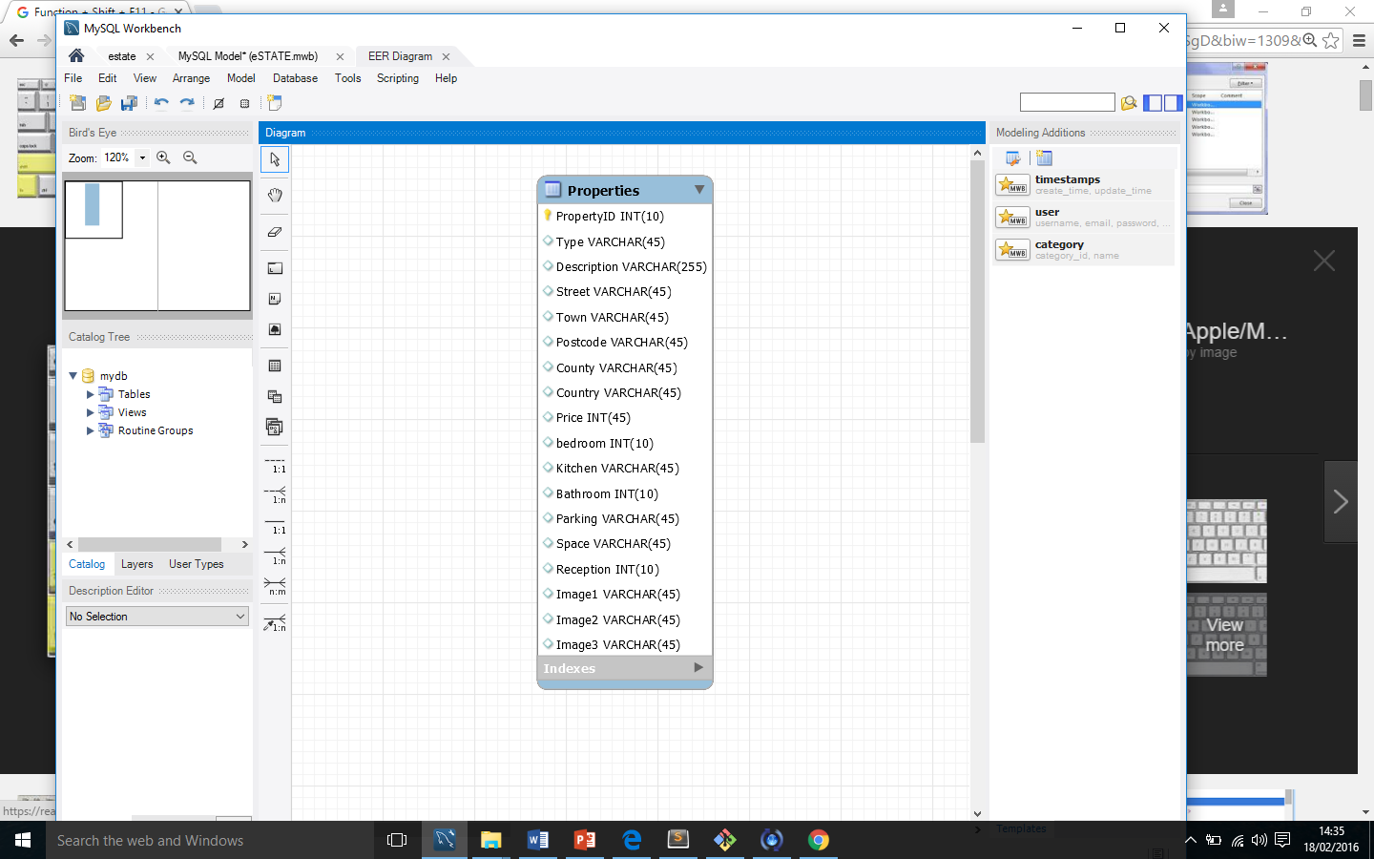

* **Members Register**

This table will hold the records of customers. Every user will be assigned with an ID (primary key). Table will also be used to create login function as website will retrieve customer information from this table.

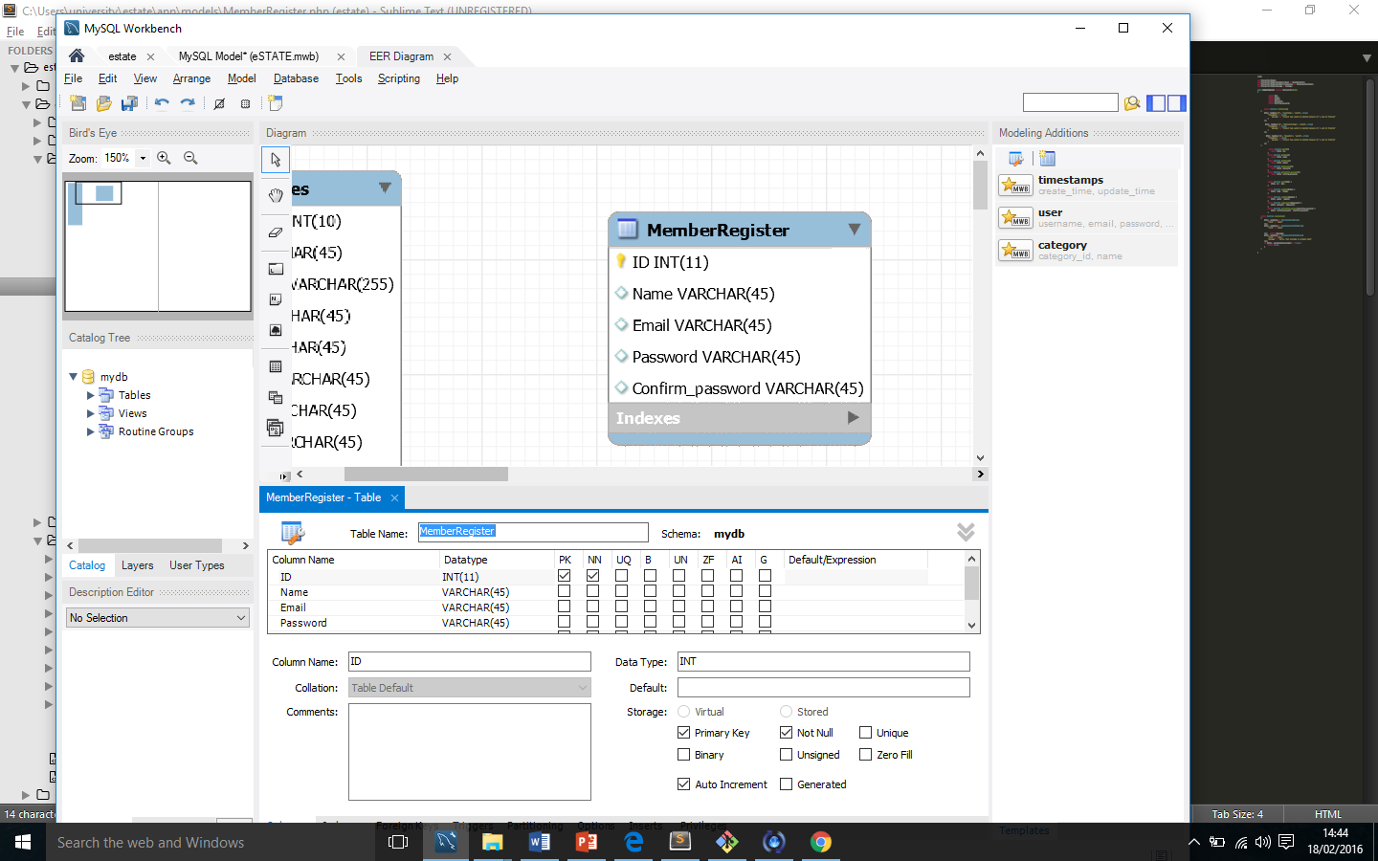

* **Valuations**

One of the function will be to allow customer to get their properties value checked by our admin staff. If user would wish to have property valued by our admin staff, the detail of property and user would be added to this table. The information would be retrieved on dashboard for admin.

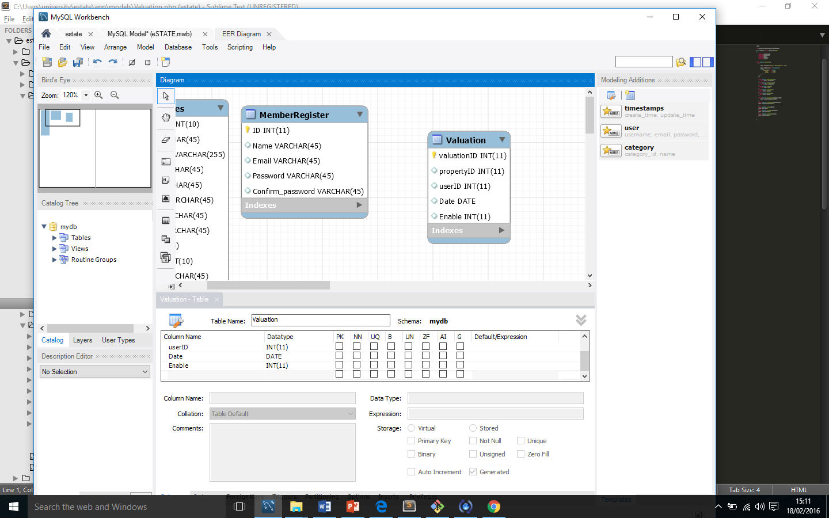

* **Favourites**

Following table is ‘*favourites’* table. Once a user will add a property to favourite, the property information will be saved in this table alongside ‘*userID*. The information from this table will be retrieved on to user panel.

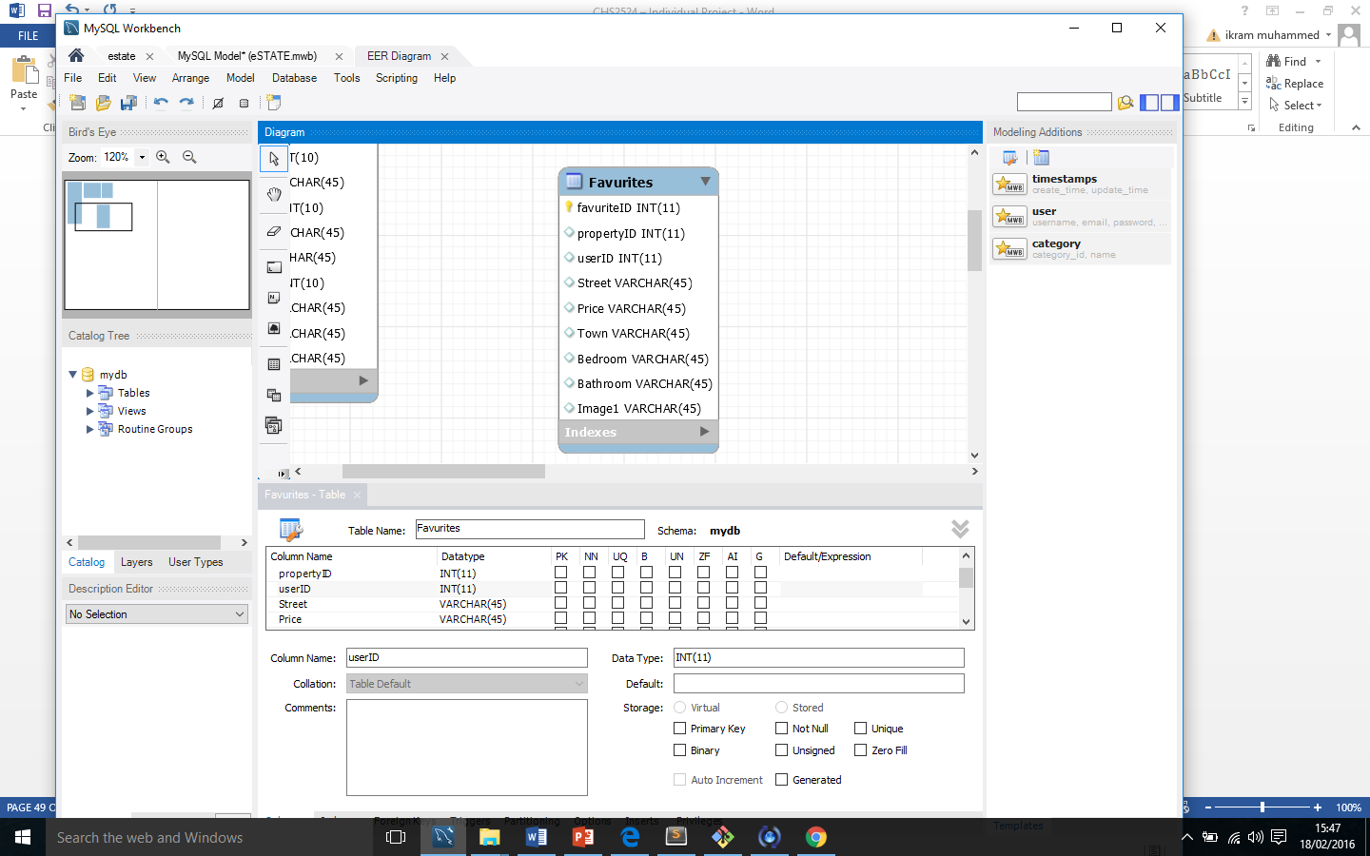

* **Listenings**

Application will require admin to approve property ad before it goes live in system. Therefore this table will include the information of properties requests. Information will be displayed on admin page for him to approve property.

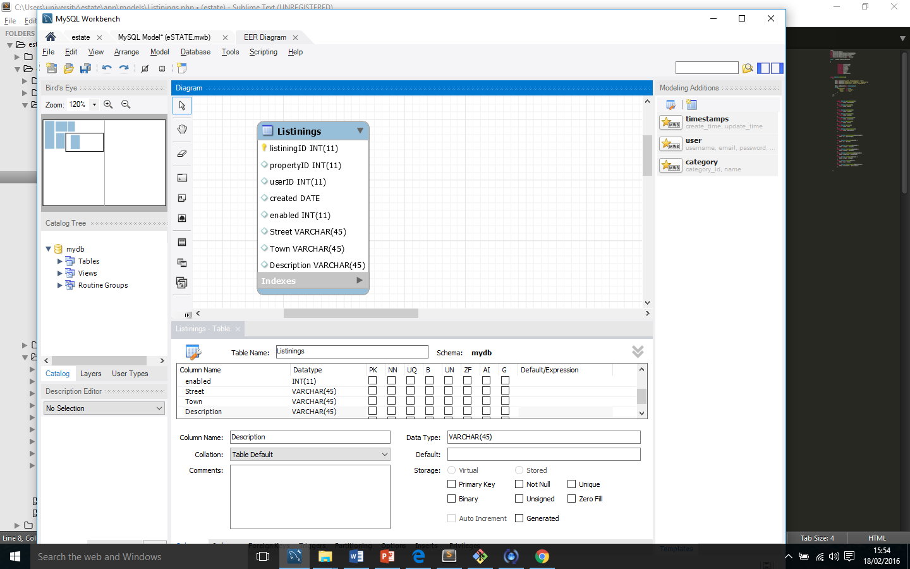

**More database tables and their descriptions are discussed in appendix 7.3**

### Entities & relationships

In section 4.5.1, the database tables are been discussed. In this, the discussion of entities and their relationship will take place.

The tables for this project will consist of following relationships.

* One to many
* Many to Many
  + - 1. **One to Many**

This form of relationship refers to entity from form table A can be associated with many entities in Table B. In following example, one member can edit many listening’s. And many listening’s can be added my one member.

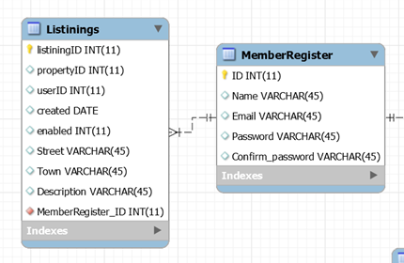

* + - 1. **Many to Many**

This form of relationship refers to many entities from form table A can be associated with many entities in Table B. Following figure shows an example of many to many (M:M) relationship. Users can add many properties; many properties can be added by many users.

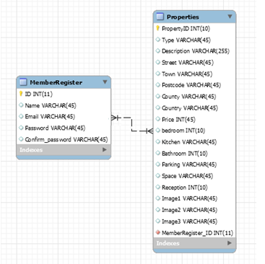One of the issue with this relationships is it cannot be implemented in a database directly.

**4.6.2.3 Benefits of Normalisation**

Normalisation is the process of organizing data in a database. This could be done through creating tables and establishing relationships. It is essential to resolve the M : M relationship shown in above figure. One way to resolve would be to add an extra table which associates with both of them tables through their primary keys.

Following example shows how the M : M relationship between Users and Properties would break.

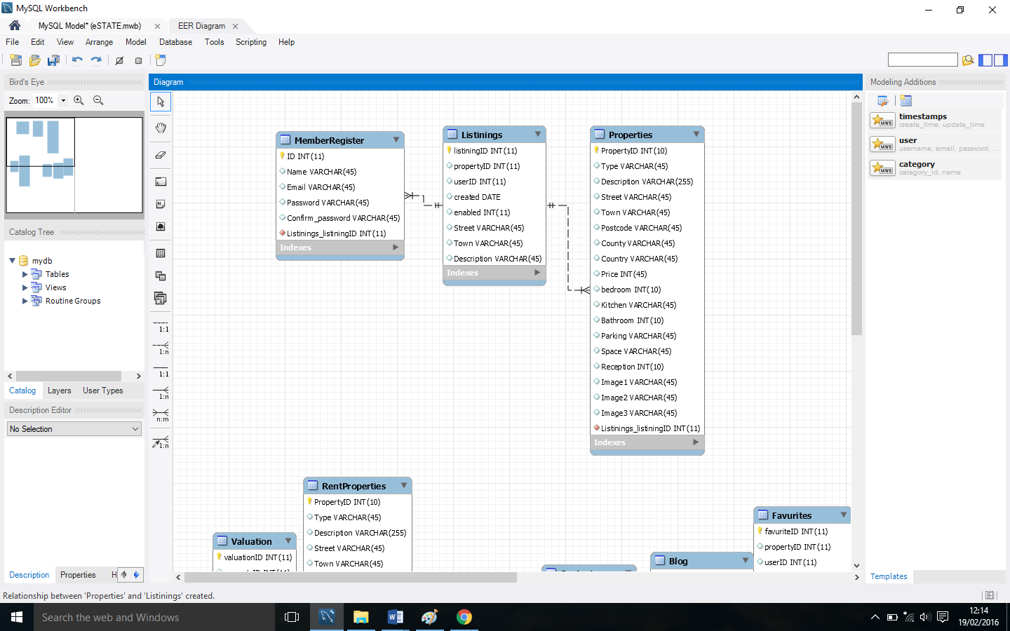

## **Product design**

According to the waterfall methodology method (Figure 6) the fourth stage is ‘product design’. For the clarity purpose it is been decided to split the product design section into two sub sections.

* UX design
* Website prototyping
* Information Architecture

### UX designs

In this section, the focus would be on creating the design of some of the website pages and determining the look of the website. According to Lee Munroe (2009) one of the stage in product design is creating wireframes.

#### **Wireframes**

The overall project will consist of many webpages therefore it us been decided to sketch the wireframes of pages that would contain the most important features of the website.

Wireframes are sketched twice for justification purpose and in final design one will be chosen that will be the most suitable.

* 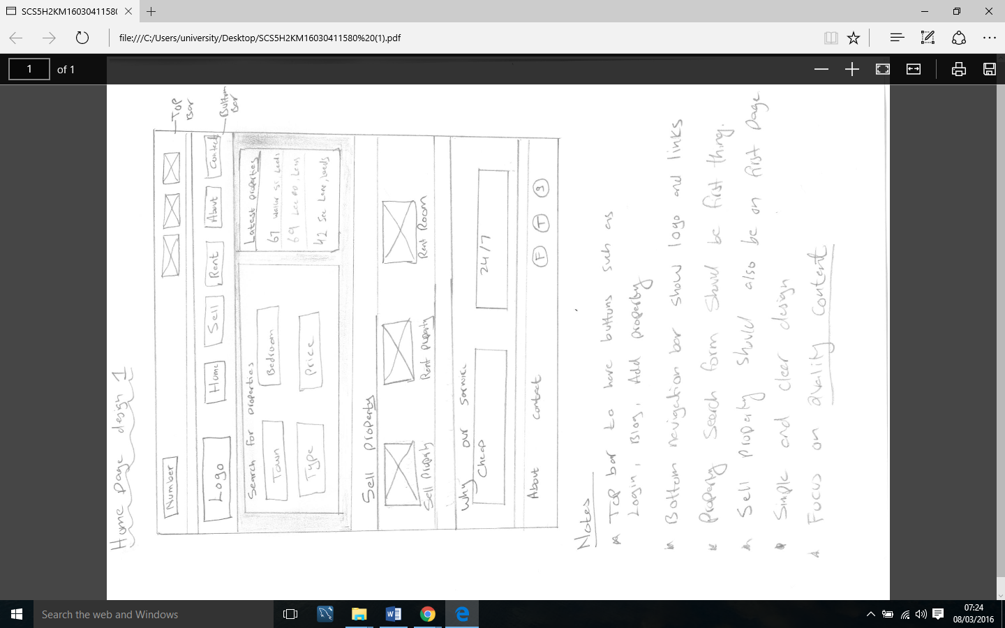**Home page: Wireframe 1**



The above wireframe illustrates what could be the home page of new online estate agency website. As it clearly says in notes and we can see in diagram, the home page could have 2 navigations bar. One for contact details and other to show links. The property search form will be displayed in middle and just below it selling property options will be displayed. There’s isn’t a lot space for text so I believe this wireframe shows simple, clean and clear homepage design.

* 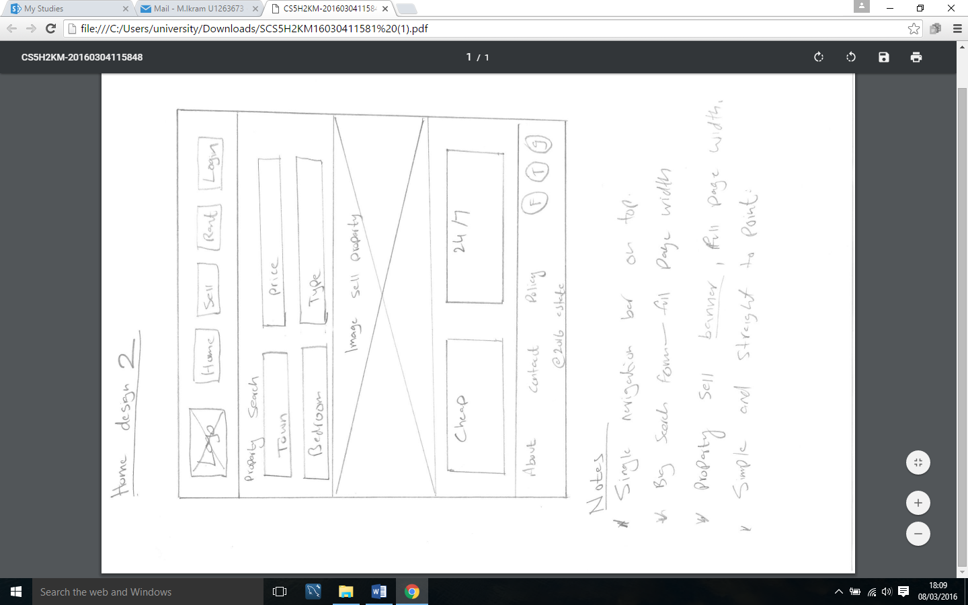**Home page: Wireframe 2**



As mentioned above, it was decided to sketch two wireframes diagram for each website page so we can justify the right choice. So, the above diagram also shows what home page may look like once the product is finished.

This wireframe presents home page that has one navigation bar on the top, big property search form just below the navigation bar. Than it would have big banner for property sellers.

* **Sell property page: Wireframe 1**

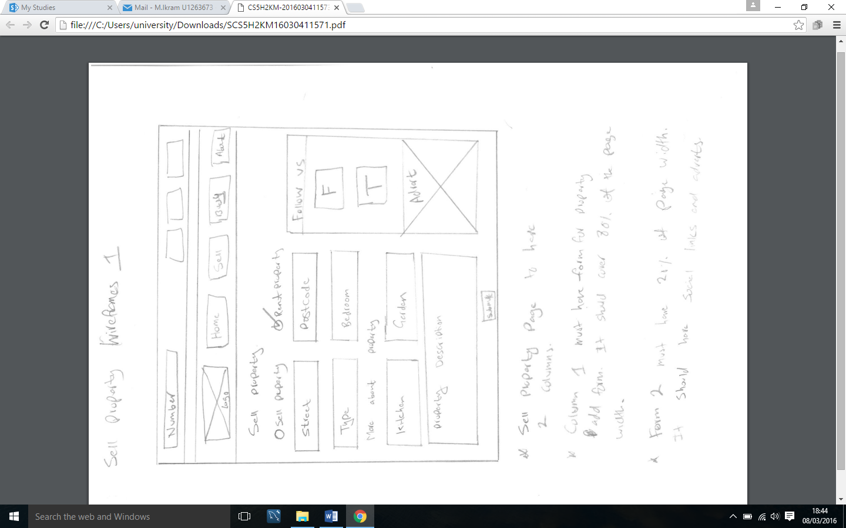

The design of the selling properties page must be simple and clear. The above sketched wireframe shows property selling page. As it can be seen notes, the page is done on 2 columns. In one column there is a form which user will complete to add property and in second columns website has social media links.

* 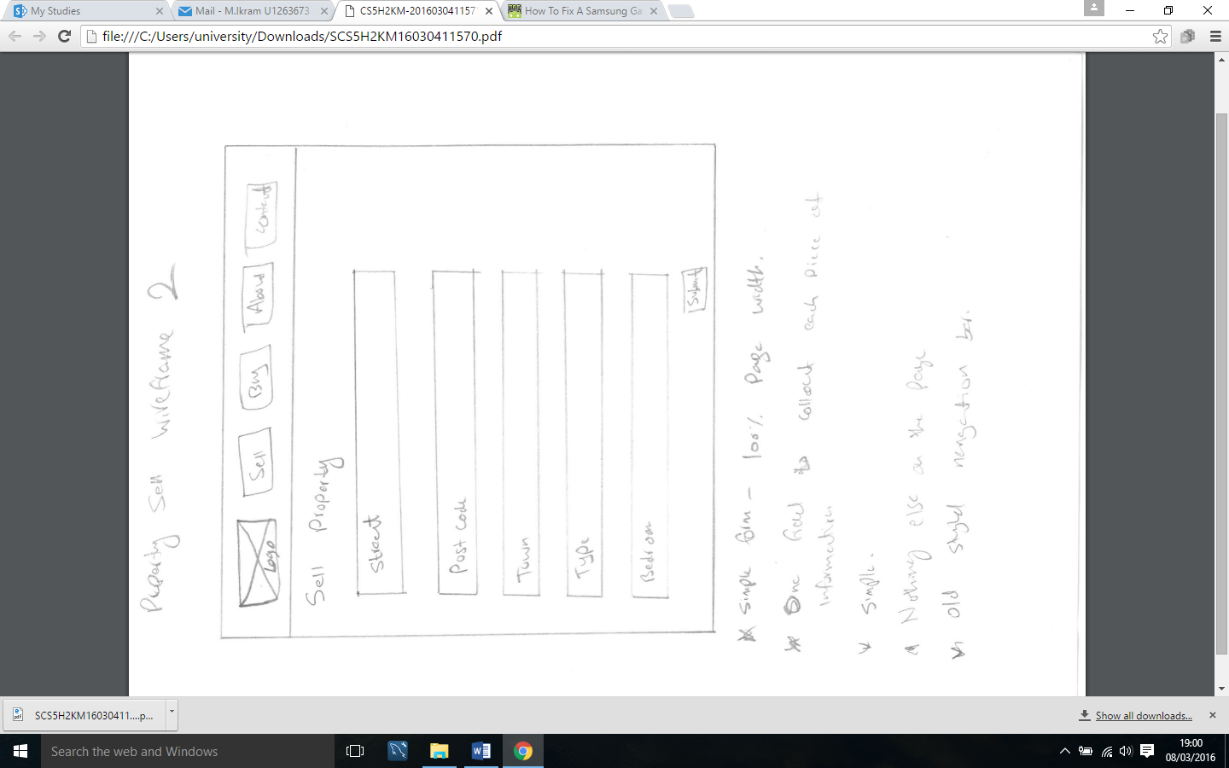**Sell property page: Wireframe 2**

This wireframe shows the second sketch of property sell form. The design on this page is very simple. According to the notes, the page would just have form in the middle of page, no other content would be displayed.

**Further wireframe are discussed in Appendix 7.4**

#### **Selection and justification of Wireframes**

#### As it is already mention above, the purpose of sketching two wireframes for each page was to give me a better understanding of designing this product. It will not just improve the product design but also enable me to measure which design best matches with user requirement therefore it will satisfy them.

Looking at the above wireframe it is been decided to choose followings wireframes for this particular project.

* ***Home page:*** *Wireframe 1*
* ***Sell property page****: Wireframe 1*
* ***Property details page:*** *Wireframe 2*

One of the reason of selecting these wireframe design because they all are consistent. All of above wireframes are simple, clear and user friendly. Secondly, the chosen wireframes have a good balance between the content. Content would be vital therefore it will be essential to have a good balance between the graphics and texts on all page.

### Product prototyping

Prototyping a product prior to development helps to test and refine the functionality of the design and to bring the product in real life (Tamara, Monosoff, ND). Another decision which was taken is to develop prototype step by step for clarity and transparency purpose. A product prototype therefore was developed based on the chosen wireframes.

#### **4.7.2.1 Logo design (Branding)**

Having a logo that is simple, memorable, timeless, and versatile is essential. In order to design such logo many tools and ideas are been used.

Here are some of initials ideas which were sketched for logo for website.

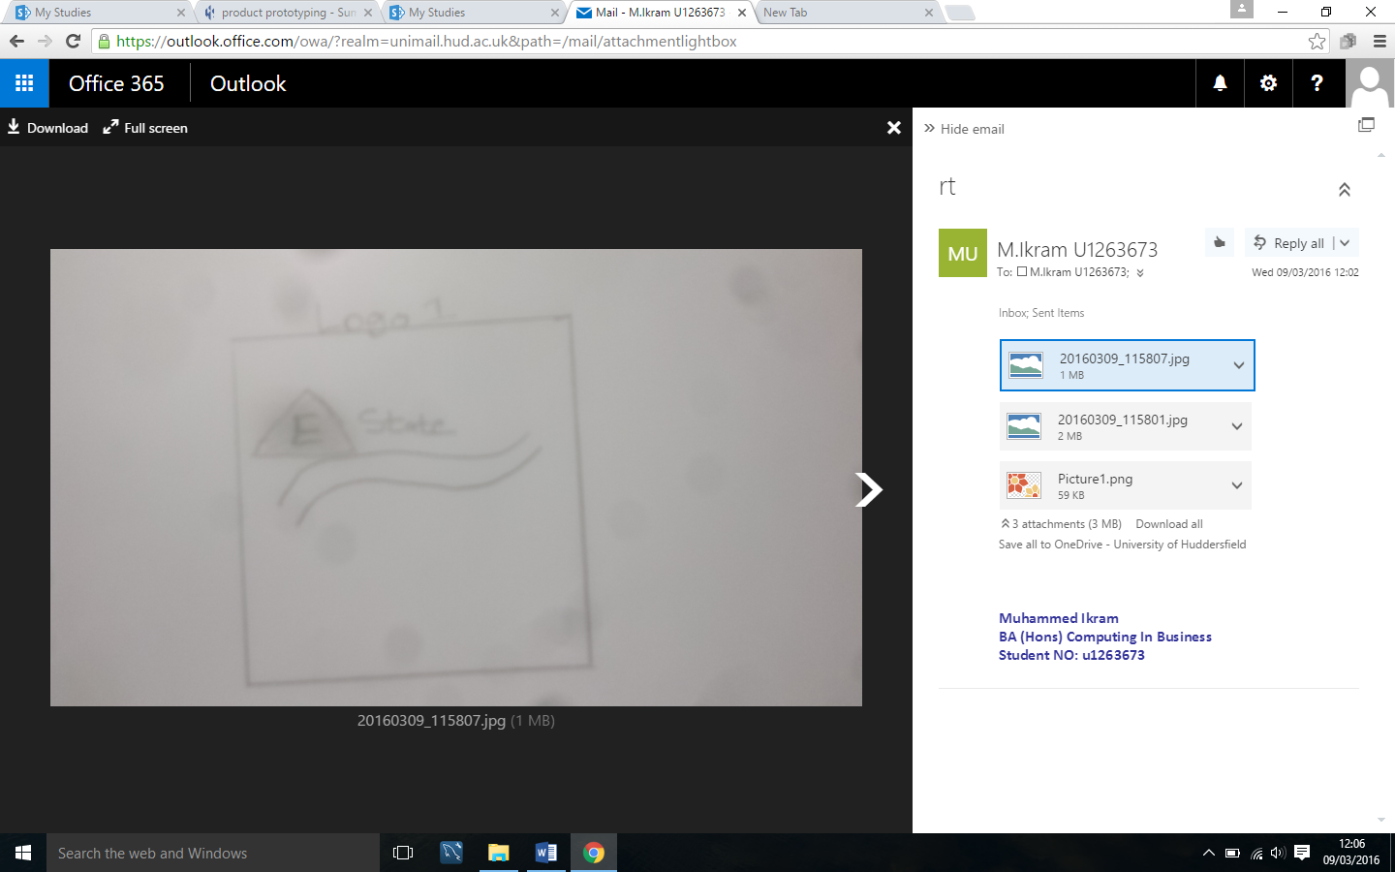

This logo looks simple and not very creative. The good thing about this idea it look quite simple. However, ‘E’ in triangle make it hard for user to read the website name.

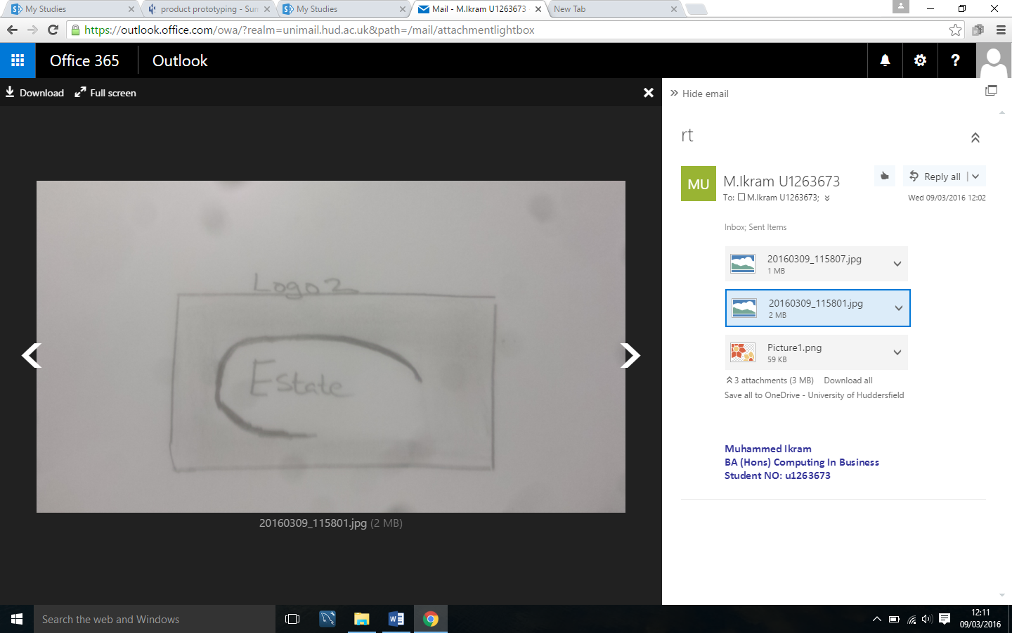Here is the second initial of logo. This time the website name would be written in oval shape which is cut from bottom left corner. The name of the website is clear simple.

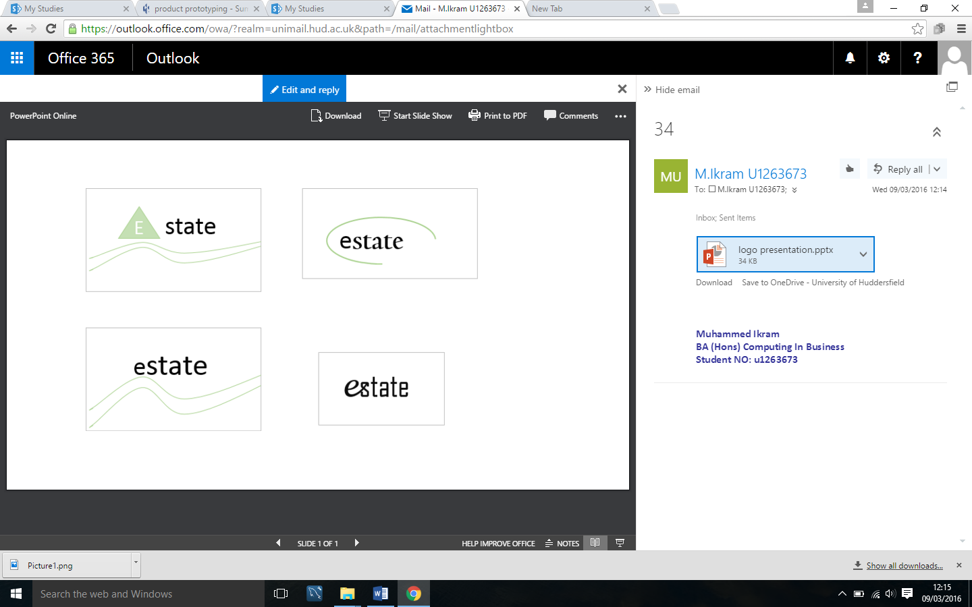

Here are sketched logo designed in MS PowerPoint. As we can see, different logos are been sketched and designed in order to create one that is simple, memorable, timeless, and versatile.

#### **4.7.2.2 Justification of chosen logo**

After some in depth design of various logos, it is been decided to select this logo (on the left) for this website. One of reason of selection tis logo is it simple. It does not have any patterns or graphics. It just has text. Therefore I believe it will be easier for audience to remember and recognise this website.

### Home page prototype (Wireframe 1)



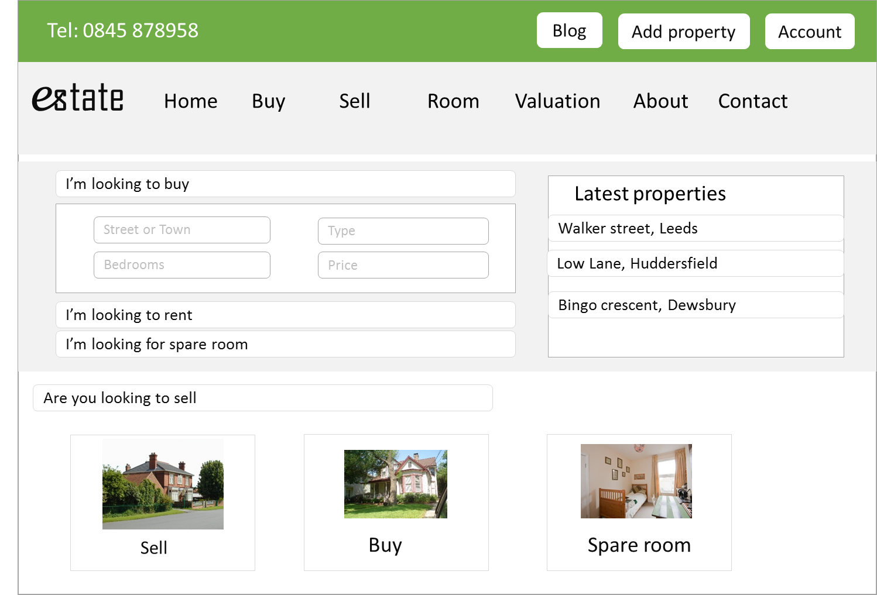

MS PowerPoint was used to generate these prototypes. As it can be seen the prototype is totally based on wireframe 1. This experiment made it clear for me that containing parts of the website in consistent bootstrap panel’s looks great way to encapsulating the content and divides pages constantly.

#### **4.7.2.4 Sell property page prototype (Wireframe 1)**

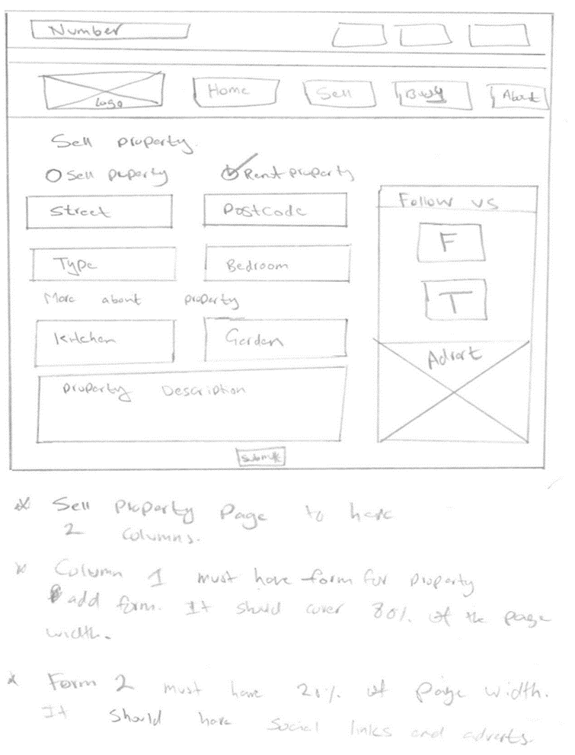



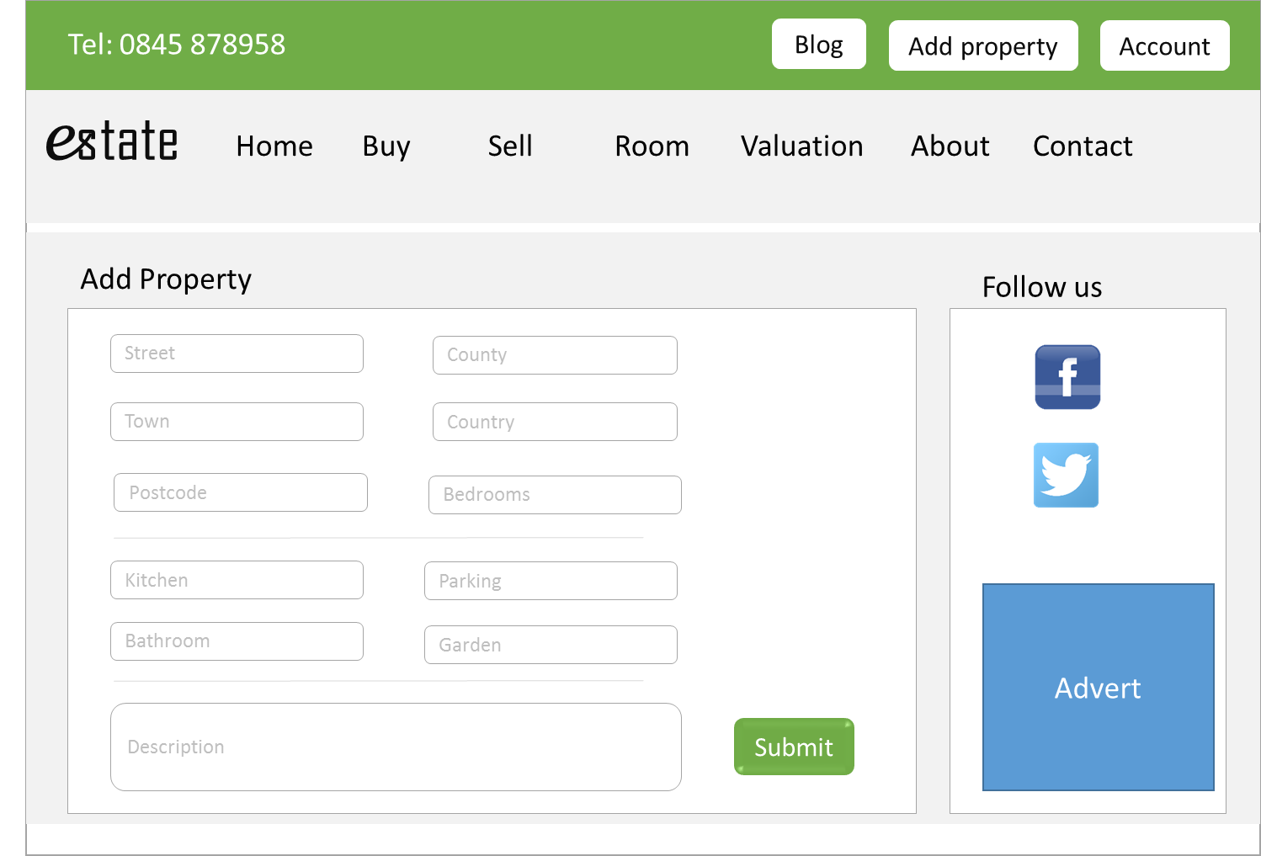

All efforts were made to bring the wireframe designs into real life. I have got a good idea now what the website will look like once it’s complete.

**More prototypes are carried out in appendix 7.5**

#### **Justification and selection of UX design**

In this section, the choice of colour, font style and font size will be justified as they all play a part to build good website.

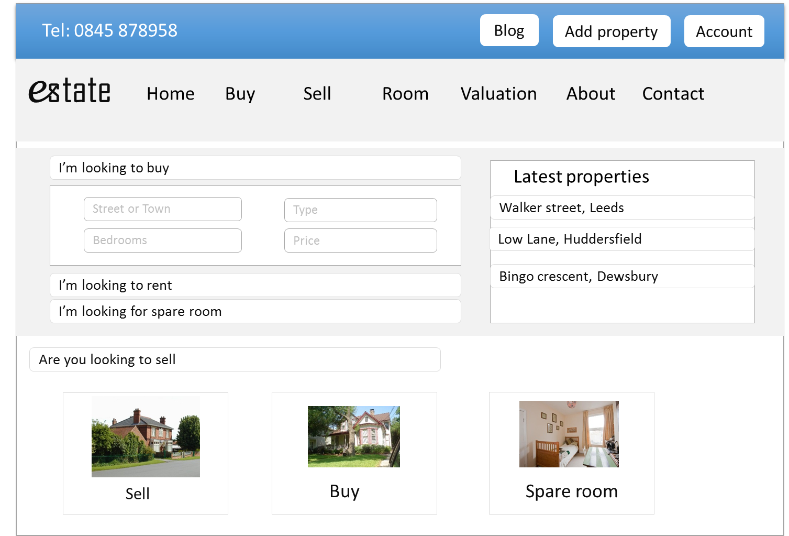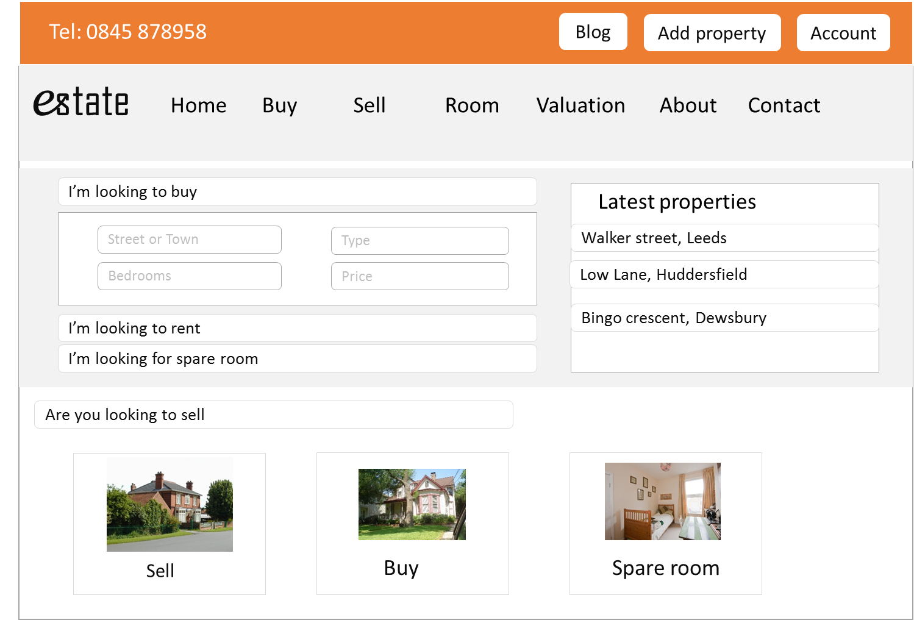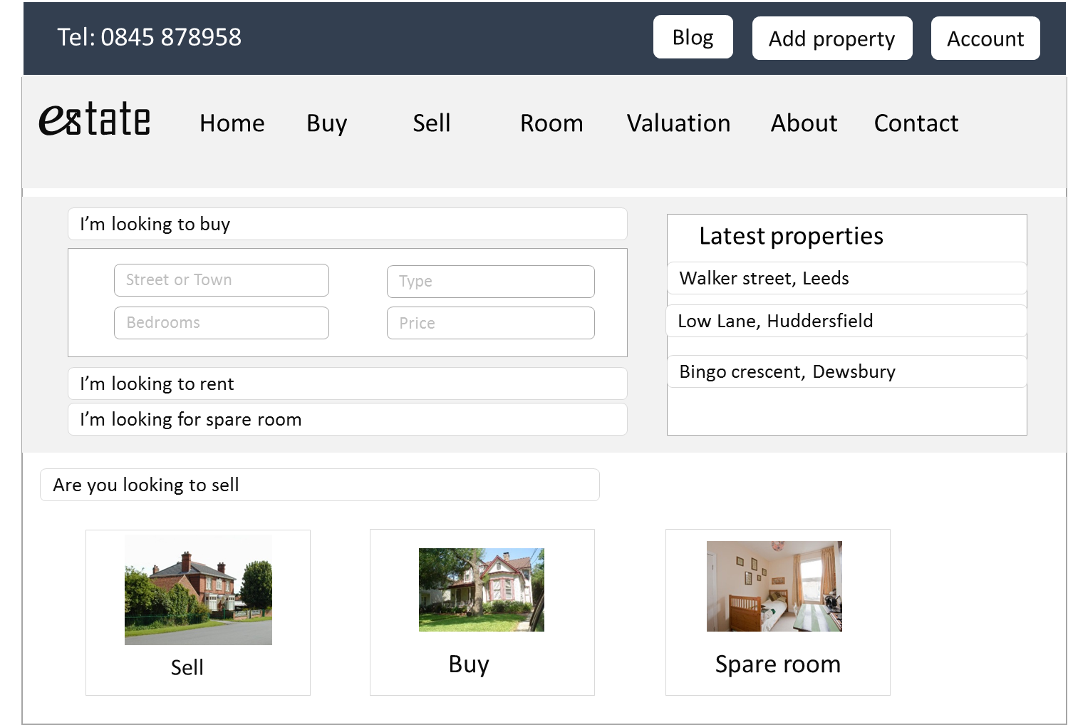

* **Colour:** *Green* colour is been selected for this estate website. One of the reason of selecting this colour is associated with the meanings of freshness and environment. And secondly, the webpage will look unique and more attractive.

The other colours are no been selected because they are all associated with existing estate agencies firms.

* **Font Size:** *Bootstrap* classes will be used for this website therefore all efforts will be put to ensure right classes are used for right texts. *<h1></h1>* will be used for page headings. The actual content will be done and bootstrap default size.
* **Font Style**

The aim will be to keep the website simple and clear. Therefore at this stage, there are no any intentions of using any specific style in the content. All the content will be done in *Arial* or *Calibri.* Having one font across the channel will add more consistency to the website.

### Information Architecture (Sitemap)

### It would be useful to design a website map while we in planning stage. A sitemap is the information architectural framework that represent website visual structure (John Koht, 2010).

An advantage of sitemap would be that it will help me to identify the pages and information this website should contain. And secondly, it will enable me to ensure pages and functions are aligned to the user’s priorities.

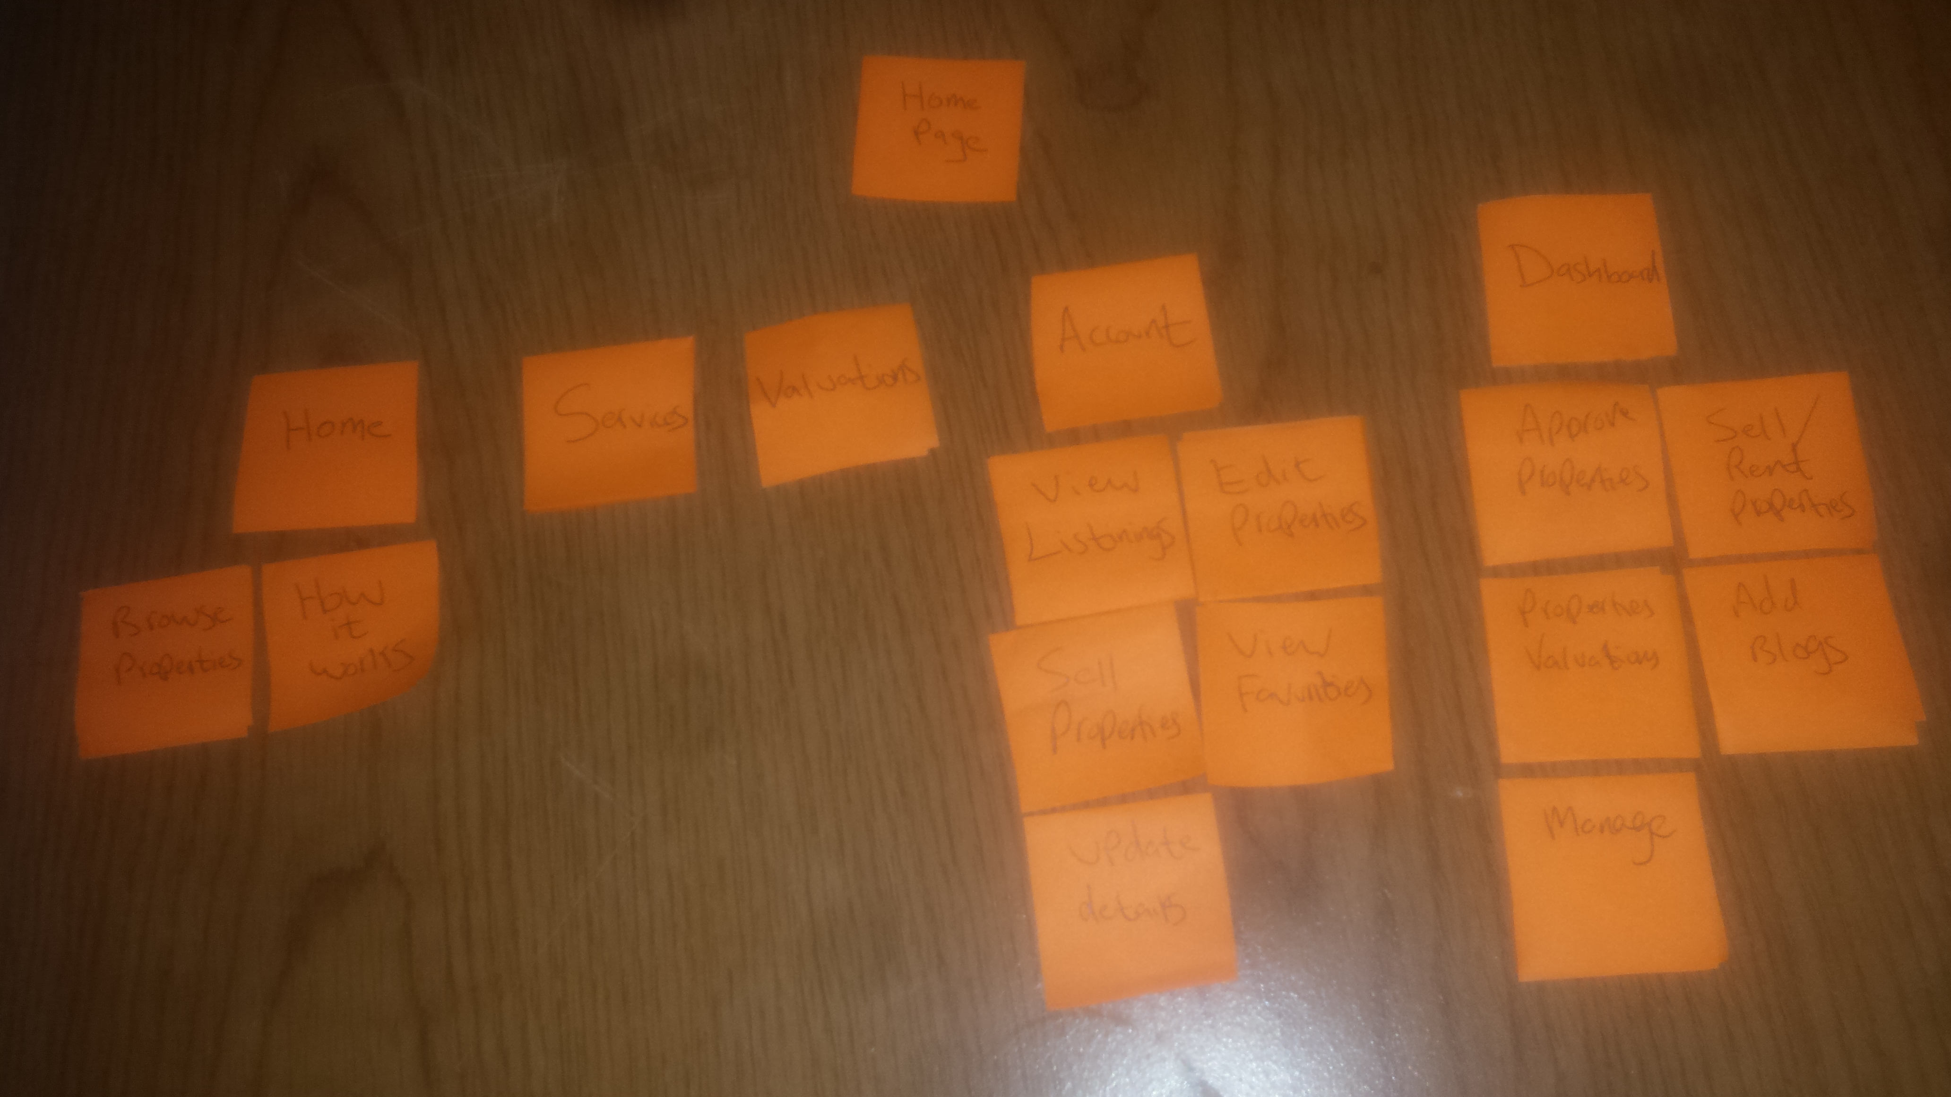Here is the sketch of basic website structure of this website.

The next stage is to re-design this idea in PowerPoint so it looks clearer.

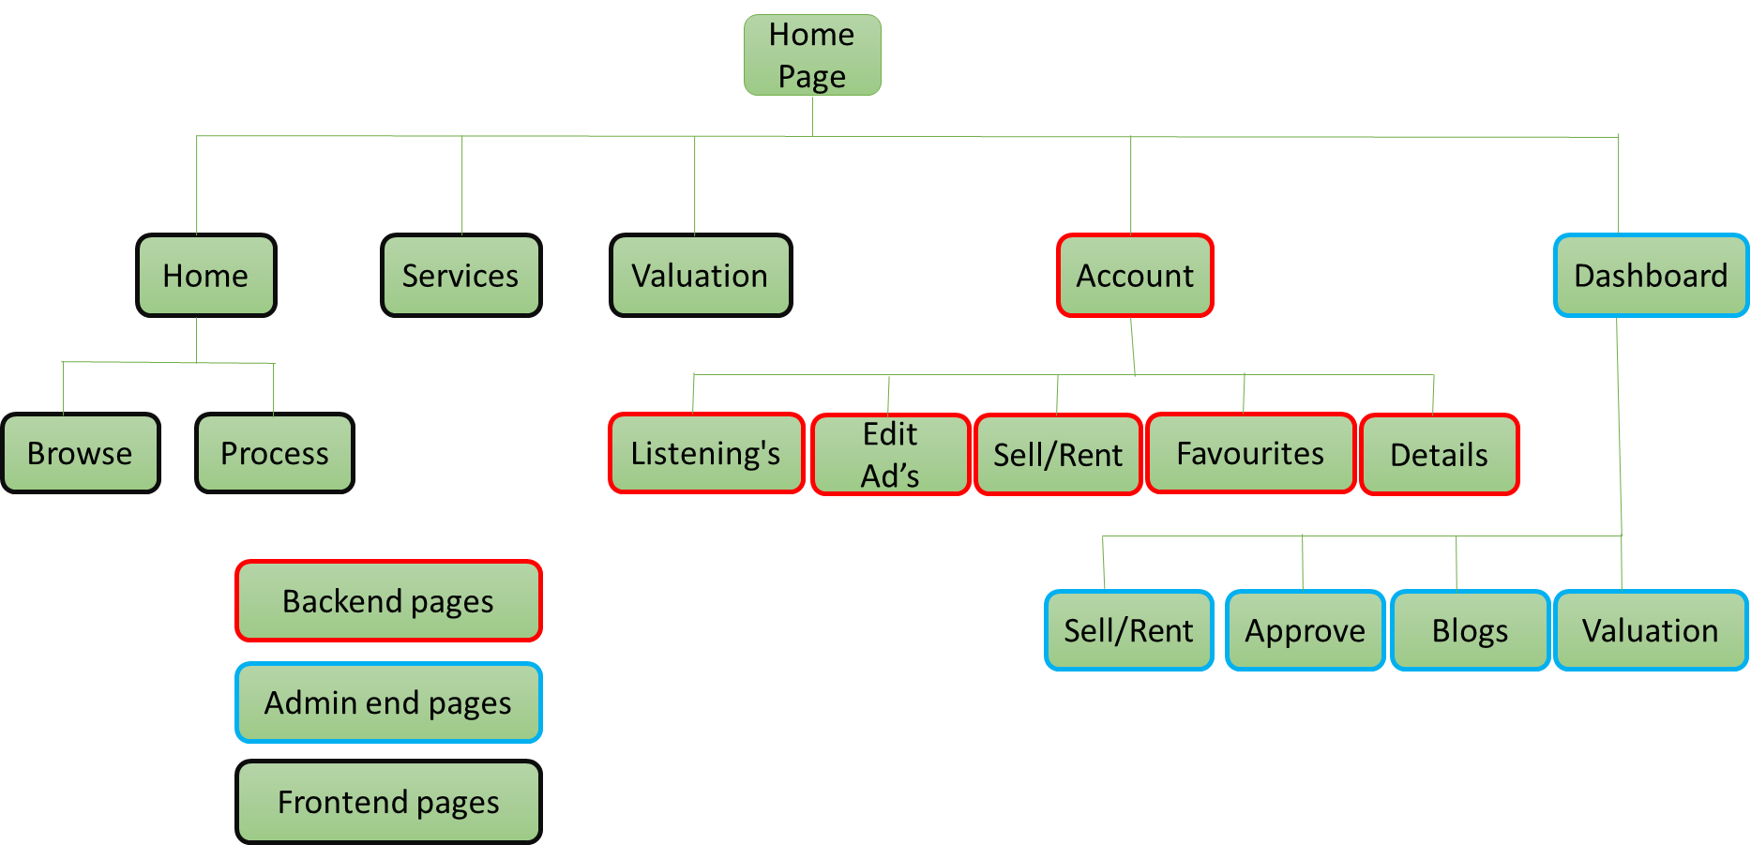MS PowerPoint is been used to develop the sketch idea into this visual design. It has given me ability to understand what the final structure will look like. Also, while at this stage I can ensure the user requirements are utilized in this sitemap so we know the final product will be fit for its purpose.

**Implementation stage**

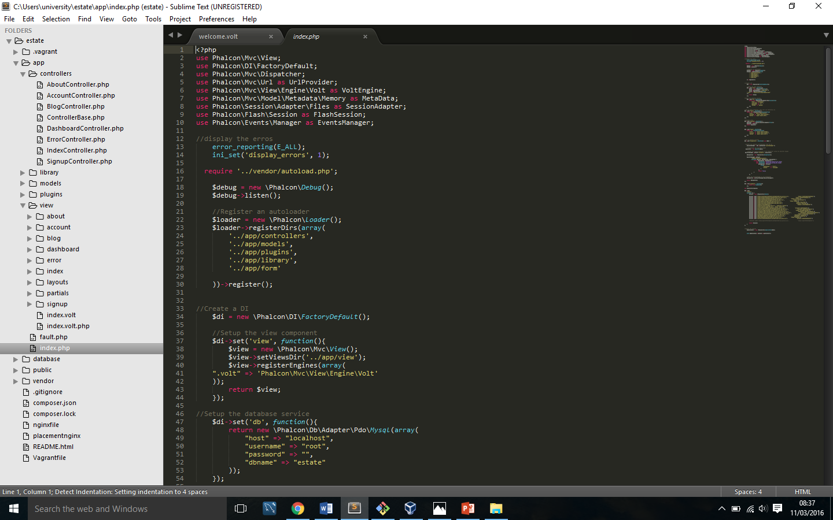

**7 Appendixes:**

**7.1** Heuristic analysis (Continued)

|  |  |  |  |
| --- | --- | --- | --- |
| *Platform* | *Problem* | *Evidence* | *Recommendation* |
| http://www.proactiveinvestors.co.uk/thumbs/upload/Company/Logo/2015_12/150x88_pur1.png | Although, the platform is for buy and selling, however from its actual design it look like only targeting property sellers. The home page of website has some excellent graphics and content however, all of those only persuading to sell property. |  | This can be improved simply in new Platform. It will be ensured the new platform will have quality graphics and content that will not be only aimed at property sellers buy also property buyers. |
| http://www.proactiveinvestors.co.uk/thumbs/upload/Company/Logo/2015_12/150x88_pur1.png | Property search form is very small and all the form elements are designed very narrow. For some users this can be hard to use as the designed is week. |  | New website will ensure the form is clear. It has all the search option that can help user to narrow down the search to find required property fast. |
| https://images2.spareroom.co.uk/img/logos/SpareRoom_en-GB.png | Very unclear search form. It has less input fields and more of radio buttons and checkboxes. It also does not allow user to narrow down search as options such as price are not included on form. |  | The new platform will ensure the search form room is clear and easier to use and it allows users to narrow down the search quickly and find suitable in few clicks. |
| https://images2.spareroom.co.uk/img/logos/SpareRoom_en-GB.png | The graphics on the home page are week. It looks dull and not appealing. There is a lot empty space across home page. The actual layout of website in middle makes it worse. The website is also not responsive. |  | It will be ensured the new website home page looks professional. It has quality graphics and content and there is good balance between them. And the actual layouts is responsive. |

**7.2** Project risks (Continued)

|  |  |  |  |  |  |
| --- | --- | --- | --- | --- | --- |
|  | **Risk** | **Probability**  **( L,M,H)** | **Impact**  **(L,M,H)** | **Effect on Project** | **Risk Reduction Actions** |
| **Development (continued)** | Loosing mysql data | L | L | In this project, there is a potential risk of losing data. If the website has insufficient amount of data or incorrect data; it will have an effect on project quality. | This risk is very simple to minimize; by backing up all the data and work regularly. Backing up data can be achieved by using online services such as ‘bitbucket.org’. |
| Issus with coding | L | H | My experience in coding is not advance therefore there maybe time where I probably struggle. | I will be required to plan ahead; looking at the previous work and use that as a help guide to tackle any coding related issues. |
| Issues with hosting | L | L | My plans are to make website live once completed using digital ocean server. There are chance my risk of getting website to work on digital ocean server | To avoid any hosting trouble; I will need to host website soon I create y first page. Then I can keep pushing my work up the server alongside development. |
| **Testing** | Lack of resources (testing tools) | L | M | User will be required come and test product on this computer as the product is done in this computer. The risk is user will not have equipment’s to test product. | To solve this issue, products will be required to be hosted on different server. This could be done using ‘digital ocean severs’ |
| Tested by right target audience | L | M | Product must be test by right target audience otherwise wrong result will be obtained. This could be another risk having to find right people to test on. | This could be done by going into traditional state agent; speaking to customers and inviting them to test this product. |

**7.3** Database design (continued)

* **Blog**

Blog will be used to keep customer up to data. The information on blogs will be saved therefore following table is designed in order to contain blog information. Once admin will post a blog, the information will be saved in following table.

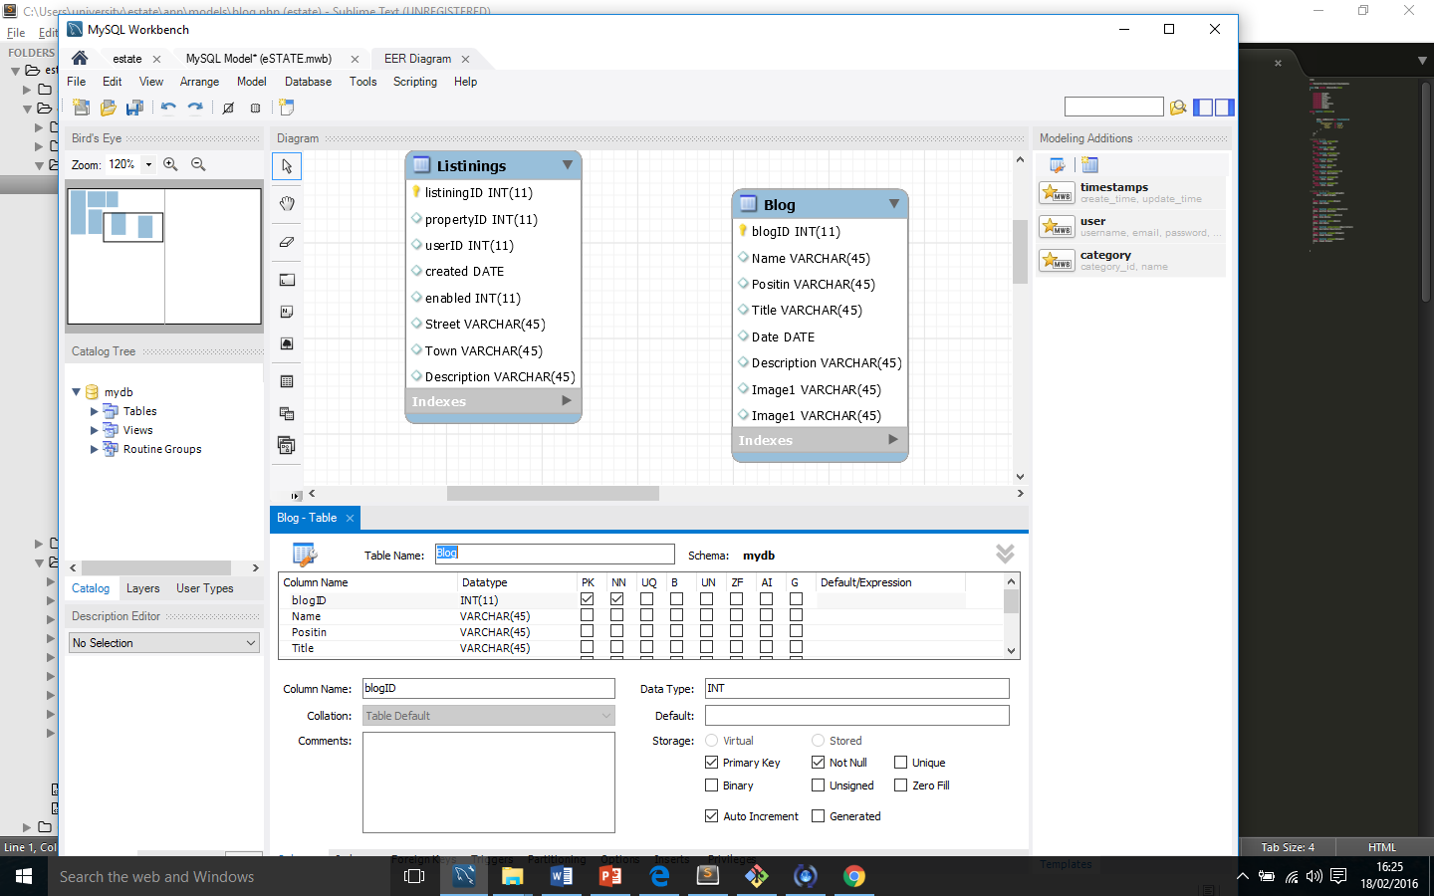

* **Contacts**

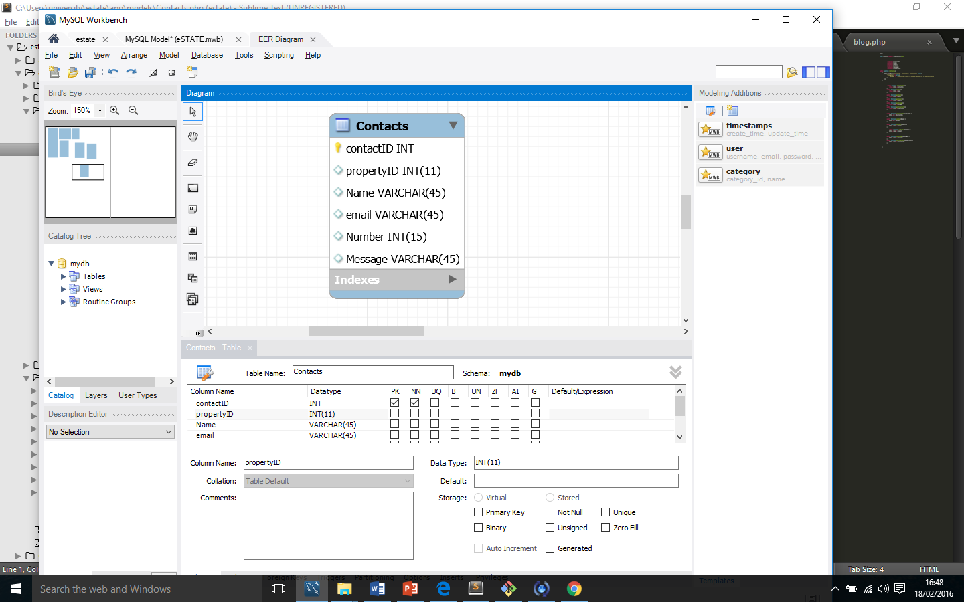The application will store the conversion between buyers and sellers for security reasons. This table will store all the messages which sellers will send to buyers.

**7.4** Product wireframes (continued)

**Property details page: Wireframe 1**

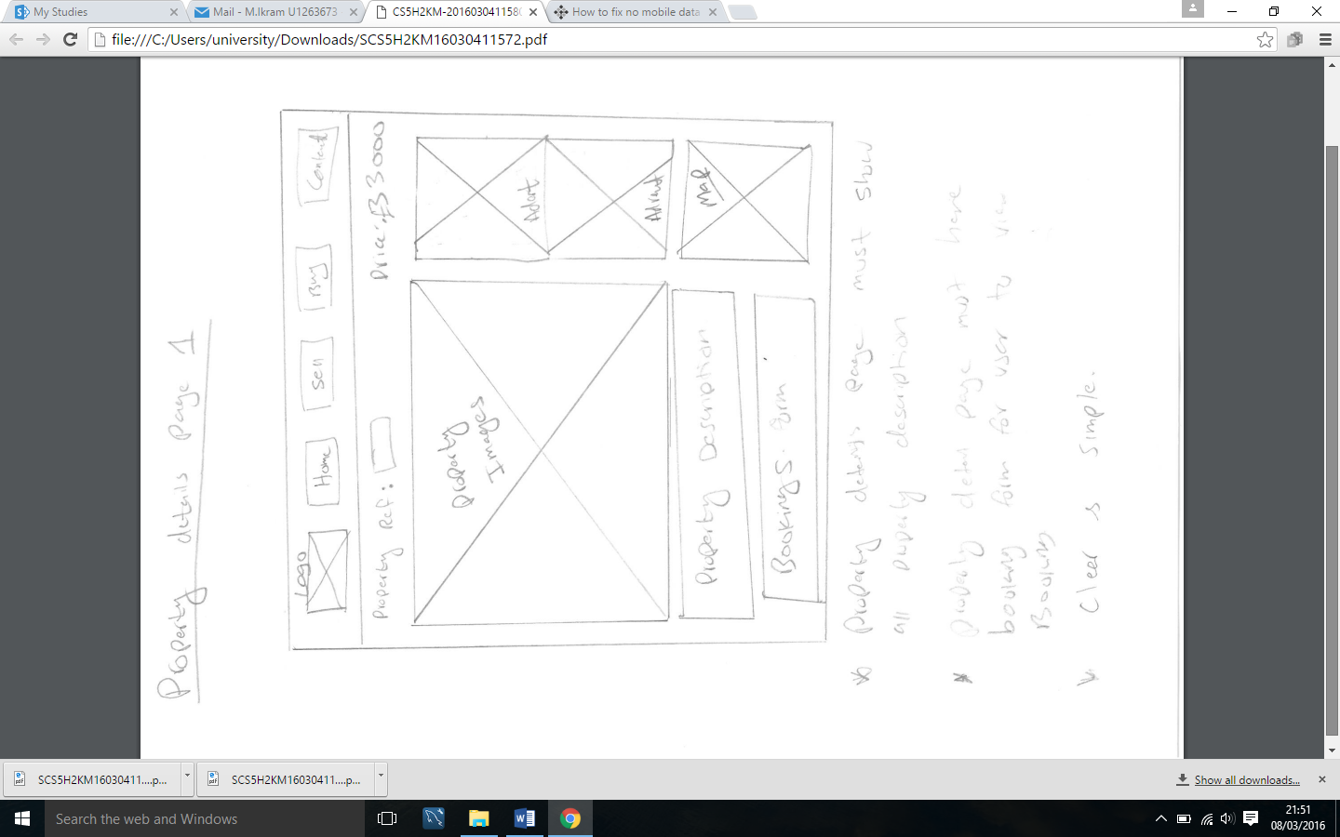

The above wireframe shows what could be property details page. As we can see the page will show a big picture of property which user will be viewings. Below the picture would be content which would include property details and description. On the side panel, the page would have seller contact details and other options such as adding to favourite.

**Property details page: Wireframe 2**

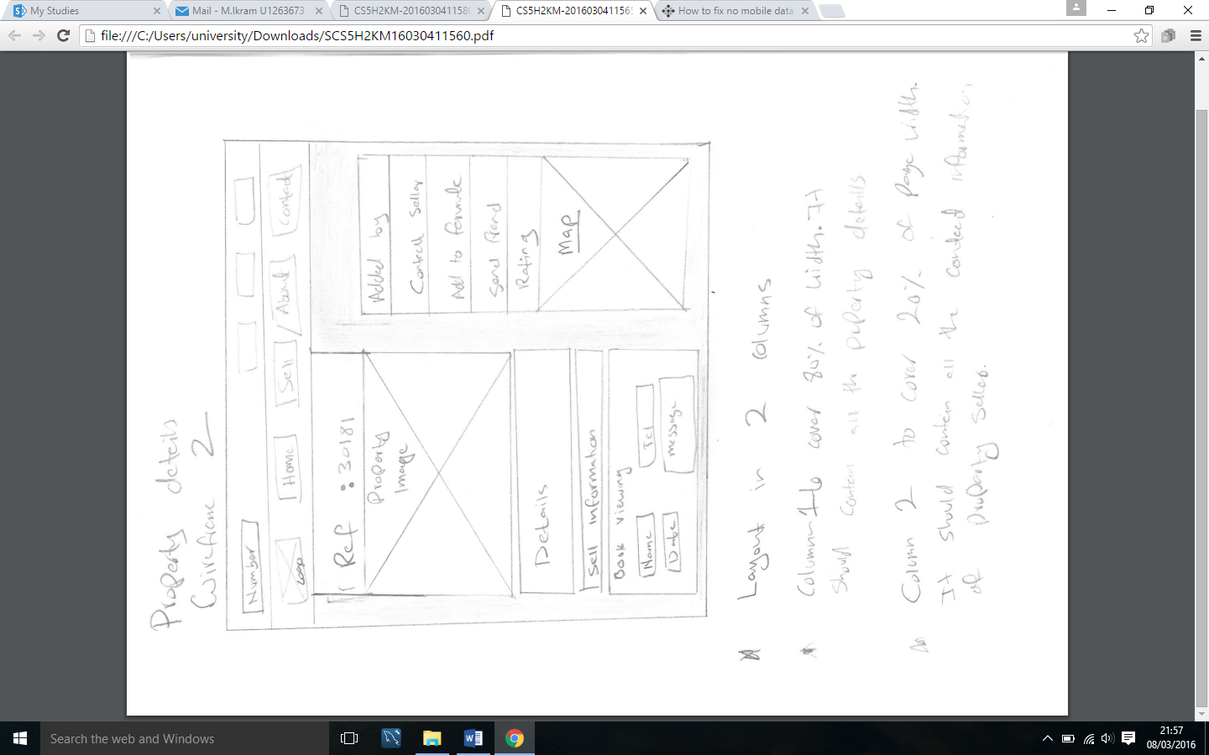

The above wireframe is the second wireframe sketch of property details page. According to this wireframe the property image would be place on top right of page with property details below. Another panel will be displayed on the right of the page which will show seller contact details as well as the map of property location.

**8 References**

1. Ricasa, T.e.d. (2015). *The Pros and Cons of Hiring a Real Estate Agent*. Retrieved from <http://www.fasthomehelp.com/how-to-sell-your-home/pros-and-cons-hiring-an-agent>.
2. Cheston , M.c.G.u.i.r.e. (2012). *How Technology is Changing the Real Estate Industry*. Retrieved from <http://www.worldwideerc.org/Resources/MOBILITYarticles/Pages/1212mcguire.aspx>.
3. Chhatrapati, R.u.p.e.s.h., Kumar, P.a.n.k.a.j., McCluskey, S.c.o.t.t., Mills, R.o.b., & Viswanathan, S.o.u.m.y.a. (2012). The Impact of Technology on Home Buying. , . Retrieved from <https://ikhlaqsidhu.files.wordpress.com/2015/01/the-impact-of-technology-on-home-buying.pdf>.
4. Tian, Y.a.n. (2008). History of E-Commerce. *Electronic Commerce: Concepts, Methodologies, Tools, and Applications,* *1* , . Retrieved from <https://books.google.co.uk/books?hl=en&lr=&id=qAMtUzo00BMC&oi=fnd&pg=PA1&dq=the+history+of+e-commerce+yan+tian&ots=-RqbiRxwK1&sig=ca2TOSUjwBTLnw0sZnSeXanaODM#v=onepage&q=the%20history%20of%20e-commerce%20yan%20tian&f=false>.
5. Dixton, T.i.m. & Marston, A.n.d.r.e.w. (2010). Retail Real Estate and the Effects of Online Shopping. , . Retrieved from <http://www.tandfonline.com/doi/pdf/10.1080/1063073022000044279>.
6. Mughal , S.a.m.i. (2015). How technology is changing the UK property market. Retrieved from <http://www.oxgadgets.com/2015/10/how-technology-is-changing-the-uk-property-market.html>.
7. E. Littlefield, J.a.m.e.s., Bao, Y.e.q.i.n.g., & L. Cook, D.o.n. (2000). Internet real estate information: are home purchasers paying attention to it?. Internet real estate information: are home purchasers paying attention to it?, , . Retrieved from <http://www.emeraldinsight.com.libaccess.hud.ac.uk/doi/pdfplus/10.1108/07363760010357787>.
8. Gee, H.a.r.o.l.d. (2010). Residential Real Estate Data on the Internet: Benefits and Limitations. , . Retrieved from http://rc4ht3qs8p.search.serialssolutions.com.libaccess.hud.ac.uk/?ctx_ver=Z39.88-2004&ctx_enc=info%3Aofi%2Fenc%3AUTF-8&rfr_id=info:sid/summon.serialssolutions.com&rft_val_fmt=info:ofi/fmt:kev:mtx:journal&rft.genre=article&rft.atitle=Residential+Real+Estate+Data+on+the+Internet%3A+Benefits+and+Limitations&rft.jtitle=Journal+of+Business+%26+Finance+Librarianship&rft.au=Gee%2C+Harold&rft.date=2010-03-02&rft.pub=Taylor+%26+Francis+Group&rft.issn=0896-3568&rft.eissn=1547-0644&rft.volume=15&rft.issue=2&rft.spage=104&rft_id=info:doi/10.1080%2F08963560903554658&rft.externalDocID=455941¶mdict=en-US.
9. Harry, M.o.u.n.t. (2014). Main content area The end of estate agents. , . Retrieved from <http://search.proquest.com.libaccess.hud.ac.uk/docview/1564135089?pq-origsite=summon>.
10. Jennifer, R.o.w.l.e.y. (2005). , . Retrieved from http://search.proquest.com.libaccess.hud.ac.uk/docview/213495561/fulltextPDF?accountid=11526.
11. CodeWizard, . (2016). explain the objects and verbs used by git. Retrieved from http://stackoverflow.com/questions/34699933/explain-the-objects-and-verbs-used-by-git.
12. Ghazarian, A.G. (2014). How to Conduct a Usability Heuristic Evaluation. Retrieved from http://designmodo.com/usability-heuristic-evaluation/.
13. RAMSOFT Consulting. Methodology. Retrieved from <http://www.ramsoft.com.au/methodology.php>.
14. Lotz, M.L. (2013). Waterfall vs. Agile: Which is the Right Development Methodology for Your Project?. Retrieved from <http://www.seguetech.com/blog/2013/07/05/waterfall-vs-agile-right-development-methodology>.
15. Williams, L.W. (2007). A Survey of Agile Development Methodologies . , . Retrieved from <http://agile.csc.ncsu.edu/SEMaterials/AgileMethods.pdf>.
16. Royce, W.R. (1970). MANAGING THE DEVELOPMENT OF LARGE SOFTWARE SYSTEMS . , . Retrieved from https://www.cs.umd.edu/class/spring2003/cmsc838p/Process/waterfall.pdf.
17. Koht, J.K. (2010). Sitemaps are the foundation of good information architecture and content strategy.. Retrieved from https://www.kohactive.com/blog/building-sitemaps/.

http://www.slideshare.net/divyeshsarkar/se-final-report